### **Introduction**

*To be done after draft review*

### **User Scenario**

#### Identifying target users?

According to the Government of Ireland Education Indicators for Ireland released in February 2023, We can notice the growth pattern in levels 7-10, level 9 Master Students growing from 21,248 back in 2017 to 30,753 in 2021, which is an increase of approximately 36.56% from 2017. ([gov.ie - Education statistics (www.gov.ie)](https://www.gov.ie/en/publication/055810-education-statistics/)) This shows us the overall popularity of Irish students graduating with Bachelor, Master and PhD in Ireland. This knowledge is especially important to understand if you're entering an ever-growing market. As said by the research paper written by Dean Ekmuti and Yunus Kathawala called ‘An Overview of Strategic Alliances’ in the conclusion of the paper “*Strategic alliances strategy has been prescribed as an important tool for attaining and maintaining competitive advantage*” and also that it “*is growing in appeal to organisations because of the cost saving achieved in execution operations*” Meaning that strategic cooperation with institutions may provide our company with a competitive advantage in a growing market. (Elmuti, D., & Kathawala, Y. (2001))

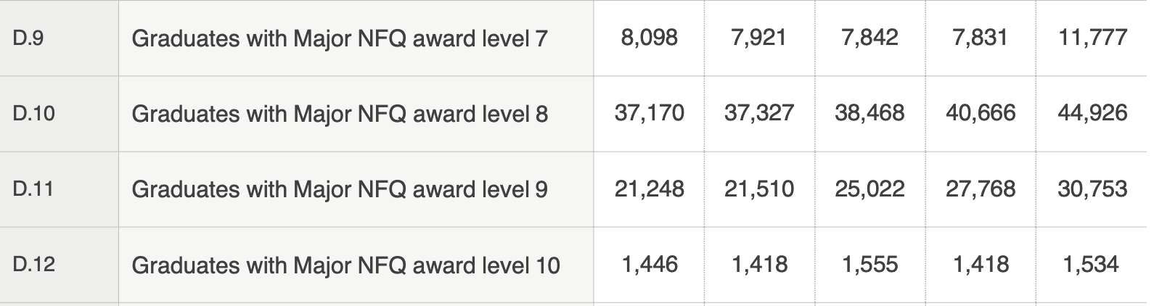

#### 

#### Why would Students study Data science?

According to the News Release Bureau of Labour Statistics U.S. Department of Labour, released on September 6th 2023. Data Science position is ranked as the 3rd out of 10 fastest growing occupations Projected 2022-32([Employment Projections - 2022-2032 (bls.gov)](https://www.bls.gov/news.release/pdf/ecopro.pdf)) Based on this information, we can assume that students are more likely to be interested in data science than ever.

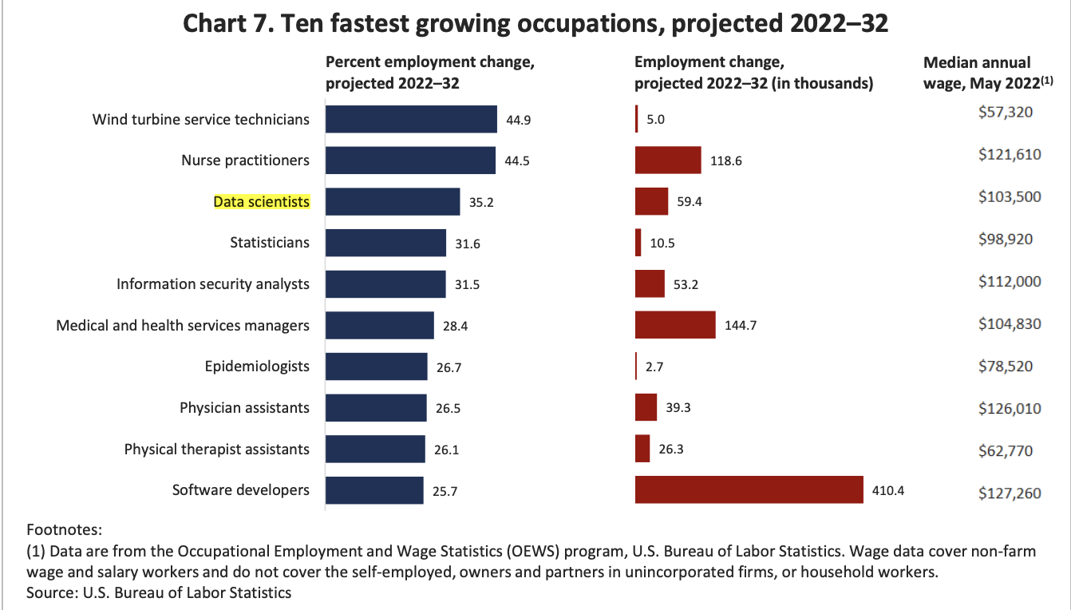

#### 

#### User Persona?

Due to the rise of students in Ireland and the rise in popularity of data science positions, we have identified our product Niche to be catered to Data science students. Here, you can see their Goals, Motivations, Frustrations and, most importantly, a use case on how DataPolish could help them in their master Journey using a fake example persona.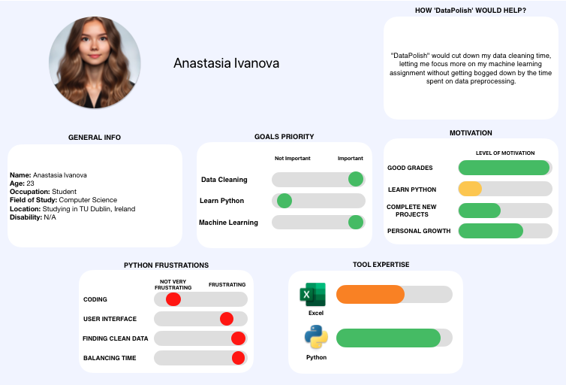

[fig.1] User persona 1. Female, age 23, studying computer science

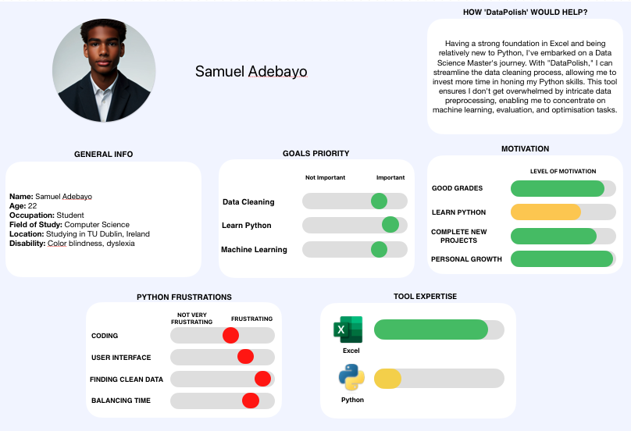

[fig.1] User persona 1. Male, age 22, studying computer science

The first and second diagrams display users we expect to use our tool. One of the students [fig.2] has colour blindness, which can be a barrier to entry for some. Our tool caters towards the unfavourable, allowing them the same opportunities as students with no vision impairment.

#### Importance of target user

The importance of target users is really important to us as we are a user-driven data tool.

Survey feedback

Before we knew our end user, we ran a test survey to identify the interest of our application on Linkedin, In the end, we achieved 24 responses, here are the results.

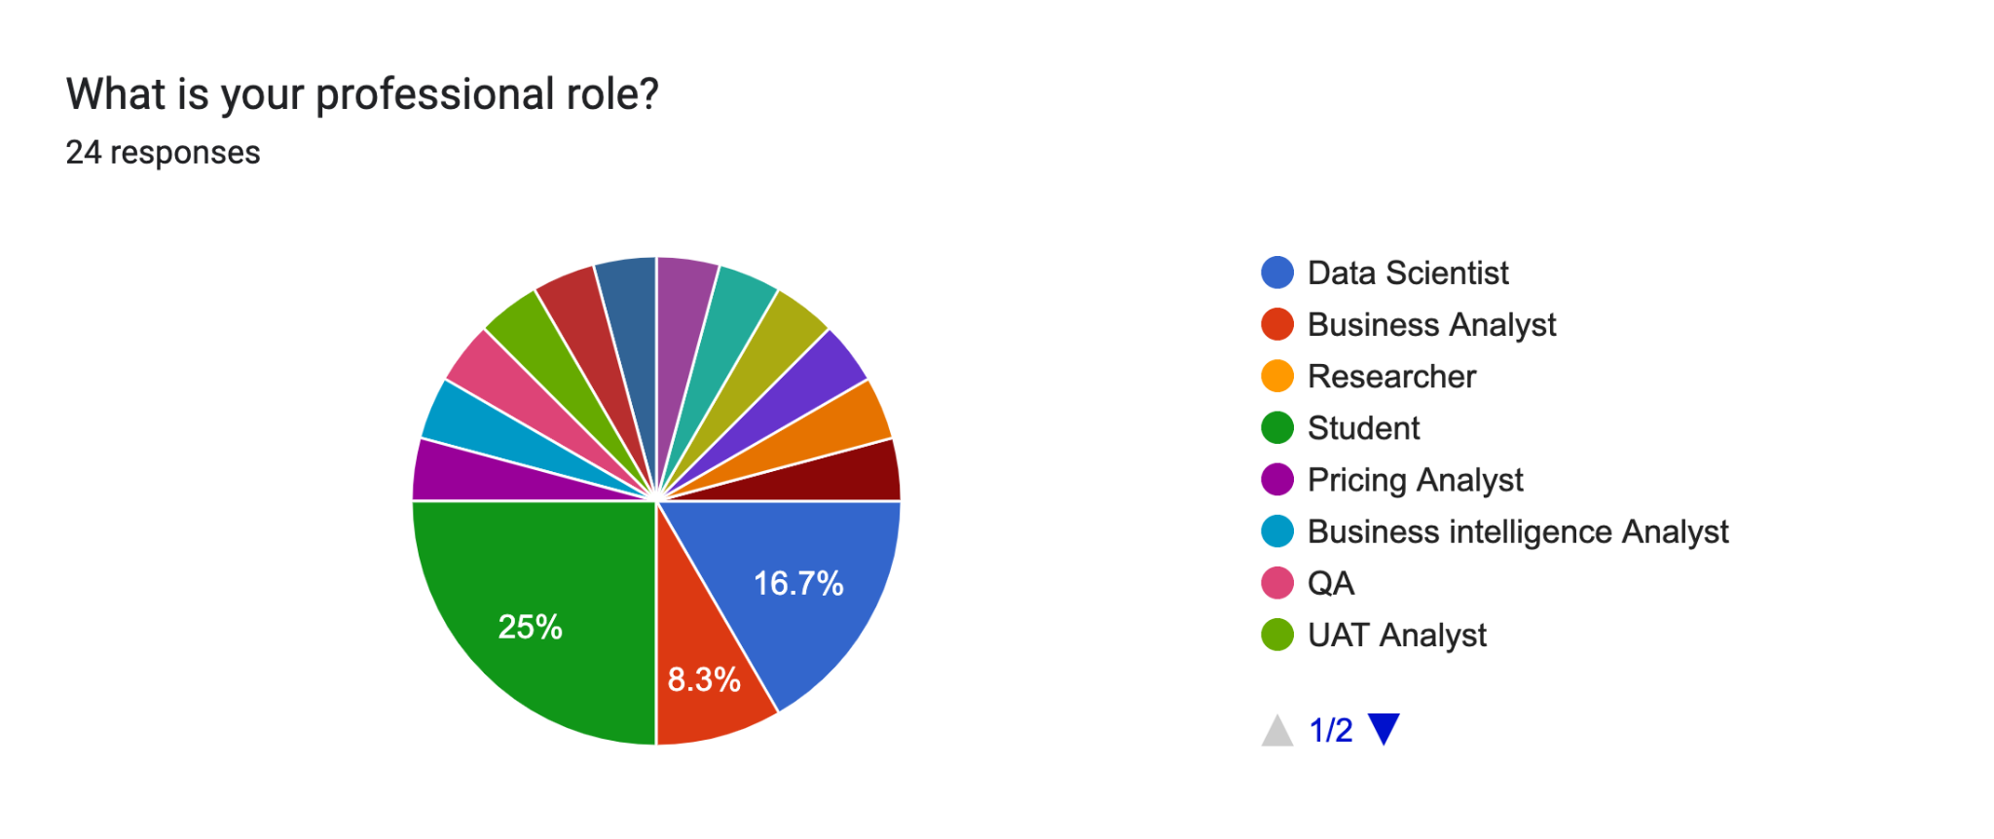

We identified that ¼ of our results came from students.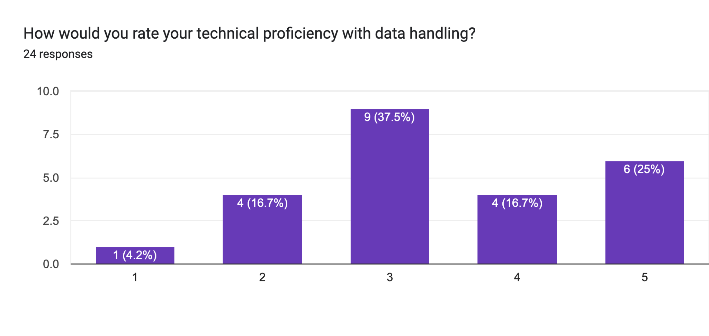Here, we asked about the proficiency of their coding abilities to get an idea of how skilled are our users on average, to which we can see a high number of people with high to medium proficiency.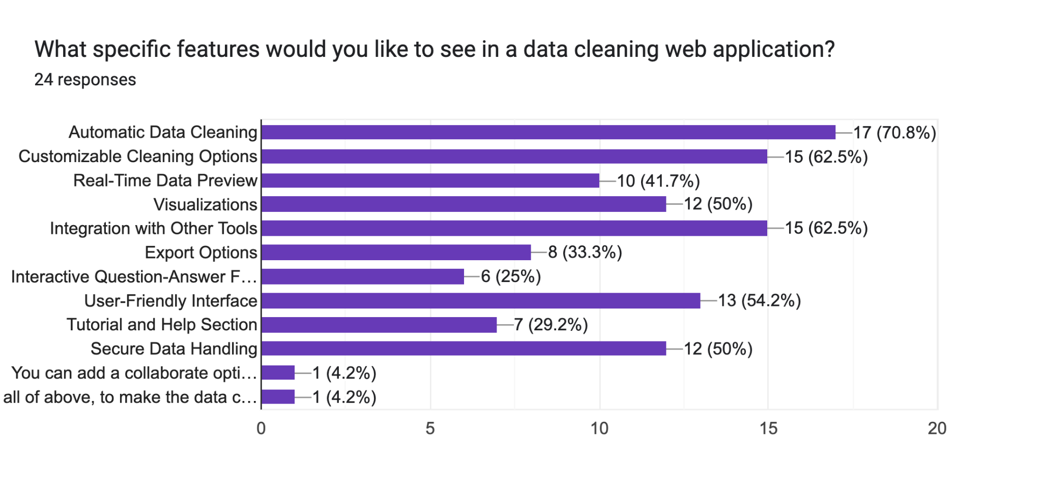Next, we aimed to identify some of the Key Initial features the end user searched for in a data-cleaning application.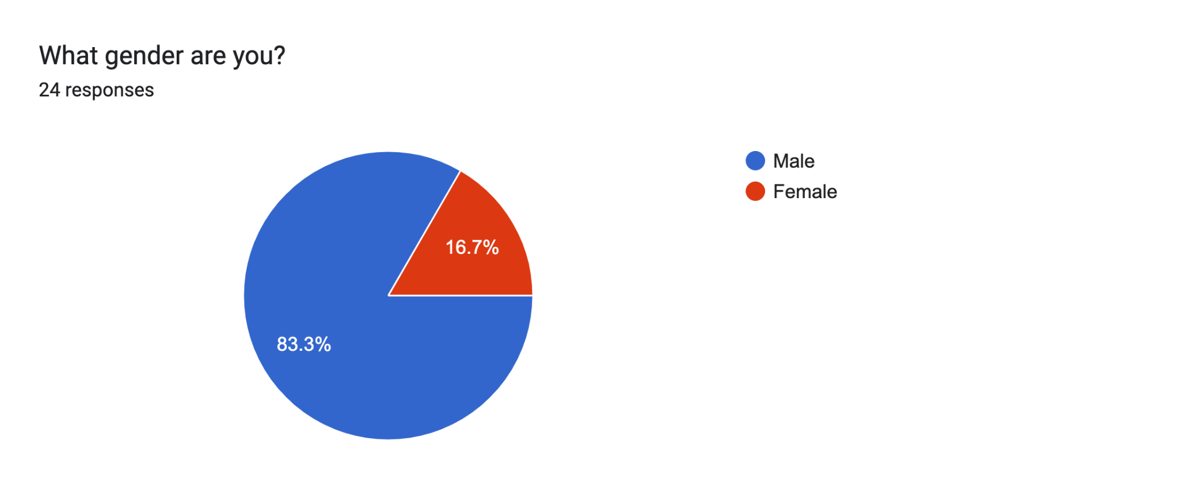Next, although the survey was very limited, we wanted to see if our gender had an impact.

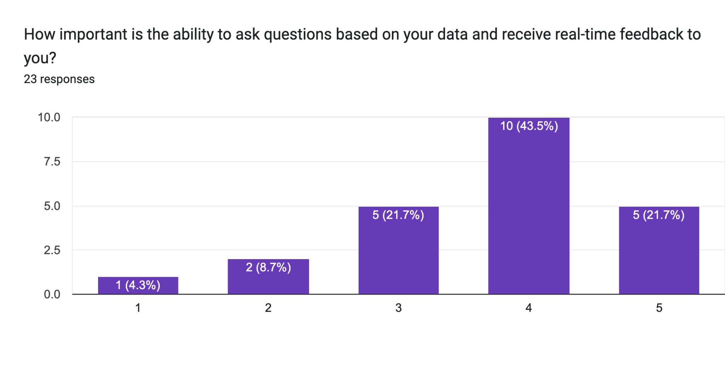As there are trending buzzwords such as gen AI, AI, and chatbot, we wanted to see if our users wanted to see that in our application.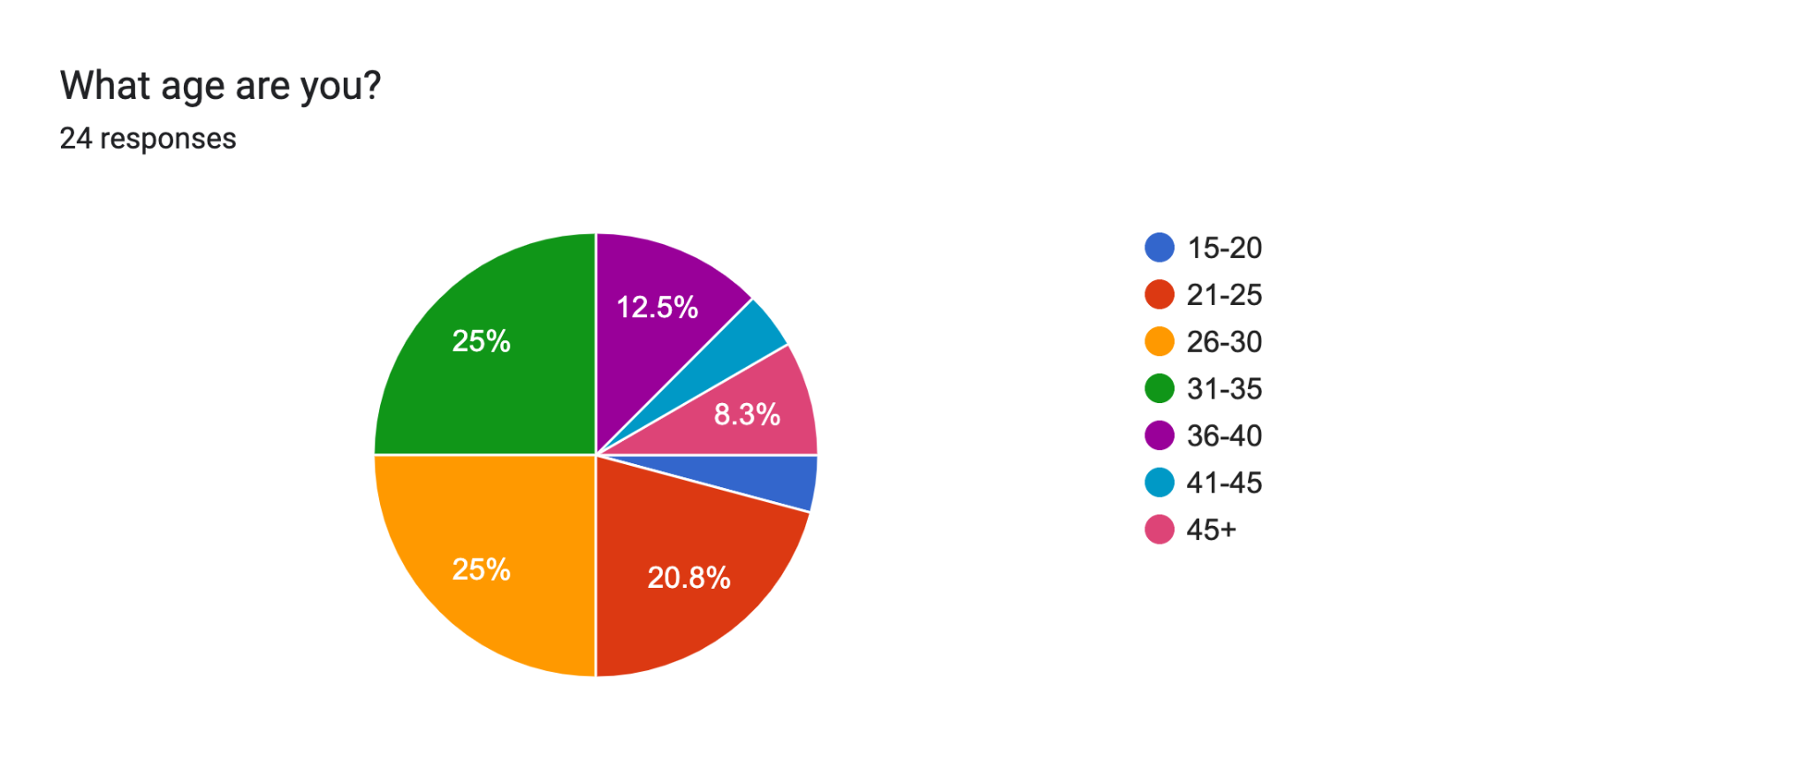

Finally, based on our survey, we wanted to see if users had an age gap.

Conclusion of the survey

Based on our survey, we analysed that everyone can benefit from our end users. Still, the specific user group of students is a great starting point as we are our prime target audience, equipping us with an edge over our competition.

#### Why would Institutions and Data Science Students want our product From their Point of view?

The challenge of data Science is not merely in interpreting clean data but in managing and rectifying dirty data. As highlighted by Chu, Ilyas, Krishnan, and Wang (2016), detecting and repairing such "dirty data" are persistent challenges and, if overlooked, can lead to flawed analytics and misguided decisions. Their research underscores a significant increase in interest from both the industrial and academic sectors in recent years. They discuss the exploration of new abstractions, interfaces, and scalability approaches to address the myriad facets of this problem. This mounting interest from academia suggests a ripe opportunity. Universities and their students actively seek solutions to these data cleaning challenges, positioning "Data Polish" as a relevant and crucial tool in this expanding market.

Interviews

The responses from our Survey were insufficient, necessitating a deeper exploration to grasp the authentic needs and preferences of our target demographic. In pursuit of an effective strategy for qualitative data acquisition, I encountered a 2001 study by Jain N. This study emphasized, 'From this study, the researcher would advocate for employing interviews as a data collection instrument in preliminary qualitative research.' In her analysis, she highlighted that, despite being time-intensive, surveys are a superior approach for gathering qualitative data that could enhance our product research (Jain, N. (2021)). Our research revealed that student users favour a straightforward solution akin to Excel for tidying and readying data, primarily to conserve time, per the GitHub recordings. (GitHub recordings link) This feedback also helped us understand the essential features users expect from our application, including statistical significance, feature diminution, and solutions for categorical attributes, like dummy variables

1. **Technical Problem**

The product to be developed, which is a data cleaning tool, is to be developed with the goal of creating a robust and user-friendly tool that streamlines the process of cleaning, transforming, and analyzing datasets. The system will aim to address a host of data cleaning and data quality challenges.

Reasons why this system exists?

Data sets are often marred with diverse quality problems like duplicates, missing values, violations of integrity constraints, and outliers. Identifying and rectifying these issues requires a systematic approach that a data cleaning tool like this provides (Chu, Ilyas, Krishnan & Wang, 2016). The initial phase of error detection involves spotting anomalies or mistakes in a database. Given the intricacies of qualitative error detection, the tool needs to address what types of errors to look for, how to detect them, and where in the system these errors are most likely to occur (Chu et al., 2016). As errors are identified, the next step is to repair them. The tool must decide what to repair (data or constraints), how to execute the repair, and where the repair needs to happen (Chu et al., 2016).

Data often undergoes numerous transformations due to structural changes, schema evolution, system migration, or integration of multiple data sources. Each scenario presents unique challenges, such as naming conflicts or differing data representations, requiring systematic cleaning processes (Rahm & Do, 2000). Data originating from a single source can have quality issues, especially if there are limited constraints on what can be entered and stored. These issues can be due to the lack of schema, inadequate data model restrictions, or poor schema design, leading to errors and inconsistencies at both the schema and instance levels (Rahm & Do, 2000). These are more pronounced when integrating multiple data sources. Independent development and maintenance of these sources lead to heterogeneity, resulting in conflicts and inconsistencies at both schema and data levels. Problems include naming conflicts, structural conflicts, differing value representations, and various data conflict types at the instance level (Rahm & Do, 2000). A significant challenge in cleaning data imported from multiple sources is identifying overlapping data, specifically matching records that refer to the same real-world entity (Rahm & Do, 2000. A data cleaning tool is needed to eliminate duplicate information and consolidate complementing information for a more consistent view on instances referring to a similar entity (Rahm & Do, 2000). Data cleaning need not only be reactive but could also be proactive, requiring tools to help in designing appropriate database schemas and integrity constraints. This measure usually helps to prevent the entry of ‘dirty data’ and hence reduces future cleaning requirements on the dataset (s). (Rahm & Do, 2000).

**Technical Problems**

1. After deploying our front-end webpage was not loading

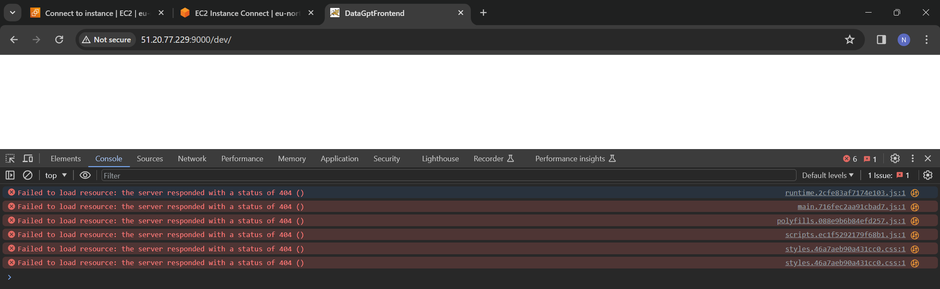

(*Angular Base Href Not Showing up in URL*, n.d.)

1. Relative path for logo and other static assets was not working after deployment. We were getting 404 error, apparently in angular for assets folder there need to navigate from current file we can start from assets folder. we can give path like ‘assest/images/img.png’ instead of ‘../../assest/images/img.png (*Images Not Loading from Assets Folder in Angular*, n.d.)
2. ‌In angular while building our application for production we were getting error. In order to fix we have increase the budget of our application in terms of size. (Gudelli, 2023)



FIG – Screenshot of error

1. While installing python in server we were getting error. All we needed it to update the package which we forgot, and it took a day to figure it out why the problem occurs *[Ubuntu] Error While Using Apt-Get Install [Archive] - Ubuntu Forums*, n.d.).

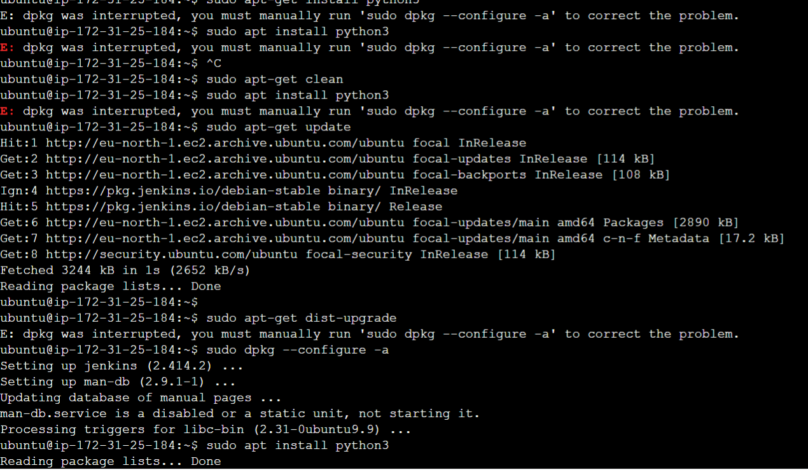

Fig: package update issue

1. ‌When users uploads multiple files with the same name snapshots where created or file is replaced in blob storage rather than creating a new file so we have too add EPOCH timestamp to fix it. Epoch time is “ is the number of seconds that have elapsed since January 1, 1970”  (*Epoch Converter*, 2010).
2. We encountered an issue during the deployment of our Spring Boot application on AWS. Initially, we were using JDK 21 for my application, but we faced compatibility problems when trying to deploy it. The tomcat server and other apps running on it did not support JDK 21, which led to deployment failures and operational issues.
3. For deploying spring boot in Tomcat server we need to use WAR Packaging because of that we created project with war packaging which led to state where application is not starting at all. So I have to go to JAR packaging then convert into WAR for deployment.

Can you review other existing systems or products that address this problem? (how do they meet or fail to meet the needs of your target users)

There are a plethora of data cleaning tools that could be deemed as our competitors. However, for the sake of brevity, two of the more well-known data cleaning application will be discussed with their merits (how they meet user needs) and demerits (how they fall short of user needs highlighted)

Oracle Analytics, in reference to its desktop application, is a tool that allows the processing of datasets from various sources to allow its users make decisions and evaluate predictions based on data. It can be found here <https://www.oracle.com/ie/business-analytics/#:~:text=Offering%20valuable%2C%20actionable%20insights%20from,Explore%20Analytics%20products>

Pros of the Oracle Analytics desktop app:

* Its Data Visualization features allows it users to create rich visual representations of data from various sources. It offers a wide range of charts, graphs, and tables to help users understand their data.
* It considers business users and provides them with the ability to analyse data without relying heavily on IT. Users can drag-and-drop data, create calculations, and produce insights.
* It’s data Integration allows the app to connect to a range of data sources, from local Excel spreadsheets to databases and cloud applications. It can blend and transform data from various sources to provide a unified view.
* Its advanced analytics allows the app go basic visualization and offer machine learning tools to enable features such clustering, forecasting and enabling deeper insights.
* Its users can create their analyses or reports which they can share s with others aiding decision making.

Cons of the Oracle Analytics desktop app:

* Its comprehensive nature makes for a steeper learning curve for features, especially when compared to more intuitive, plug-and-play analytics tools. Particularly since it uses a lot of SQL syntax to make transformations to columns it is not very beginner friendly.
* The mac desktop version is loaded with a myriad of technical deficiencies and couldn’t import CSV files, which serves as a significant concern since many datasets are in CSV’s.
* Oracle solutions are known to be on the pricier side, especially for small to medium-sized businesses. The licensing and maintenance costs can be a barrier for some organizations particularly the cloud suite of the analytics tool.
* Some users have reported challenges when connecting to non-Oracle sources or third-party tools.

Open refine (formerly google refine) , in reference to its desktop application, is a tool that can help transform datasets into other formats or carry out transformations on the dataset itself depending on the user’s choice. It can be found here <https://openrefine.org/>

Pros of the Open refine desktop app:

* Open Refine records all changes applied to the data, allowing users track and copy changes to another dataset if needed.
* It can handle large amounts of data instances efficiently, allowing users to process and clean data that would be cumbersome in traditional spreadsheet software.
* It can allow a variety of transformations and conversions from one data format to another.

Cons of the Open refine desktop app:

* Legacy UI feel as its kept much of its original UI from the original google refine application.
* It does not support advanced data visualizations.
* It is not built to perform complex statistical analysis.
* It does not integrate directly with data storage systems (databases)

1. **Technical solution**

System overview

Data polish is a web-based application primarily for students who want to perform data science on dataset. Our application aids by cleaning datasets prior to any machine learning or deep learning techniques are performed on their dataset. This application has very simple user interface which is easy to operate.

Below is a high-level of the system flow of our application:

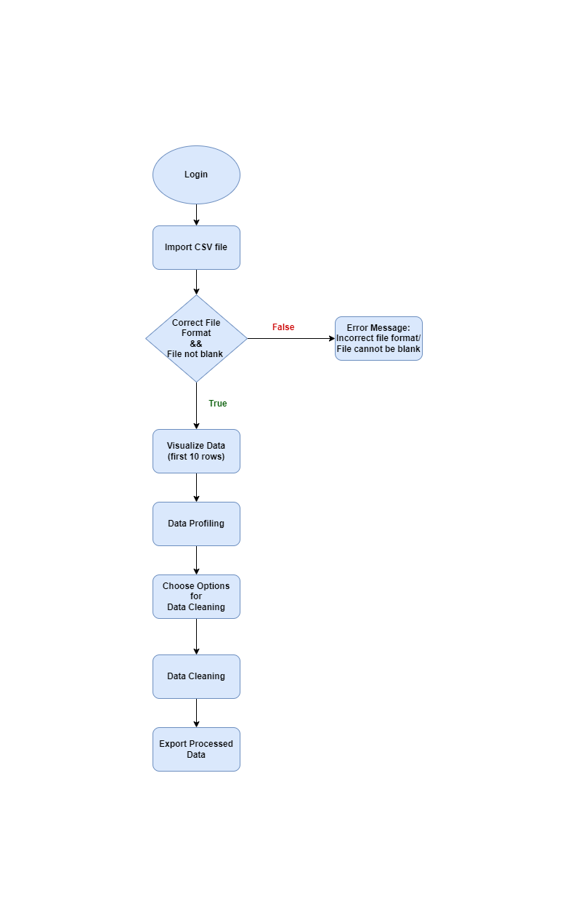

Next, we designed a high-level use case diagram as shown below:

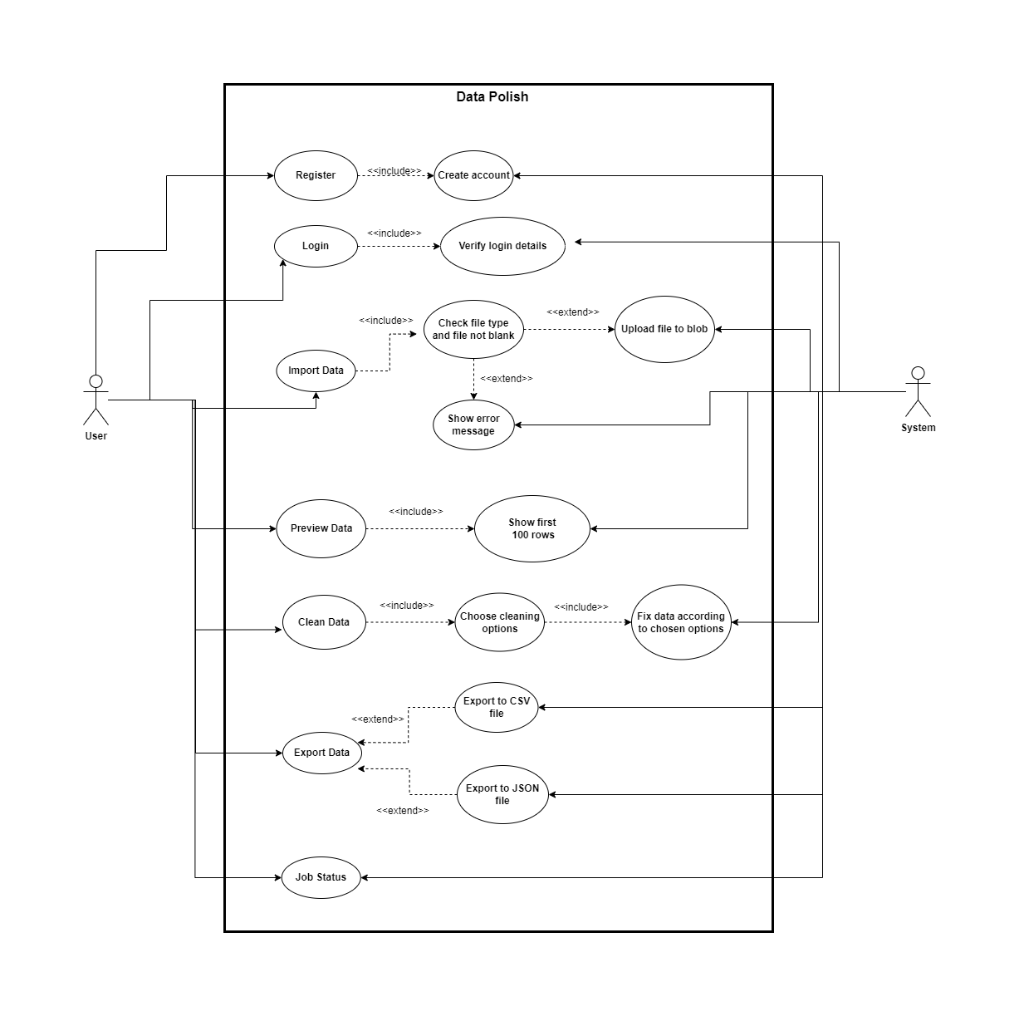

The site map diagram attached below shows a hierarchical view of the pages on our web application, starting with the home page at the top.

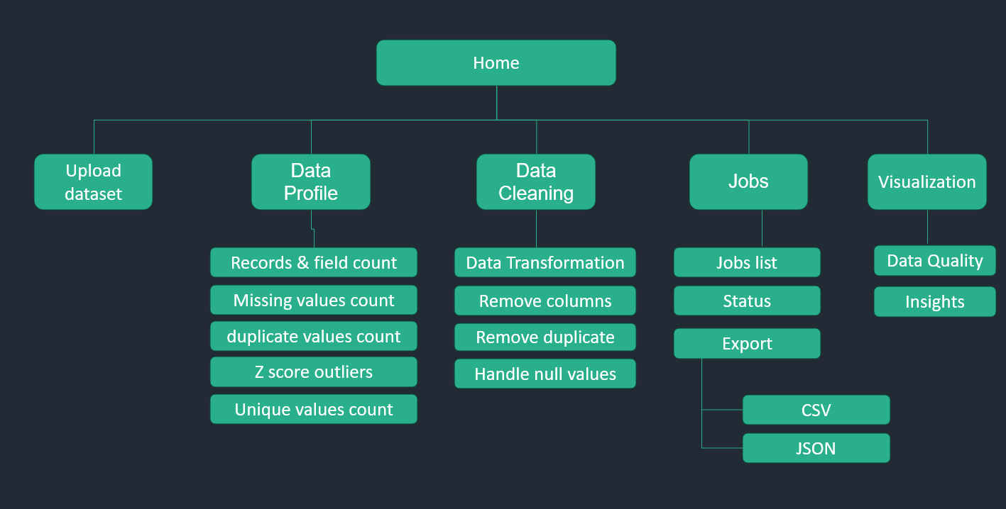

Data import

To start with the ‘Data Polish’ journey, end user first needs to upload their dataset on the application. In this page, they can upload their file using drag and drop feature. Also, using the ‘+ Choose’ button they can browse their device to upload the file. At present, we are accepting .csv file format only but we have plans of including more file formats in upcoming releases. After choosing the file, user can click ‘Upload’ button to upload it or if they have chosen a wrong file they can click on ‘Cancel’. It will be saved in the cloud and user will get an unique ID (job ID) to track the progress.

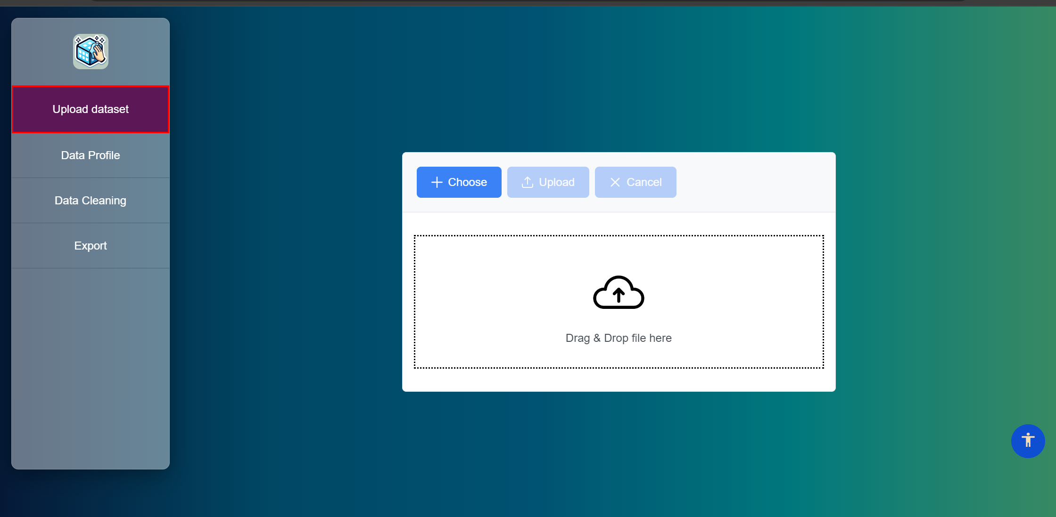

Data Profile

In this page, end user will be able to get the current data quality index and full profile of the dataset they have uploaded. This will show some analysis of their data quality which will help them to understand what the issues with it are. By clicking on the ‘Missing Values’, ‘Outlier - Scatter’, ‘Outlier – Table’ and ‘Unique Values’, users can check the particular analysis presented in those diagrams which pops up when they click it. We have a plan of replacing this page to an interactive dashboard in next month.

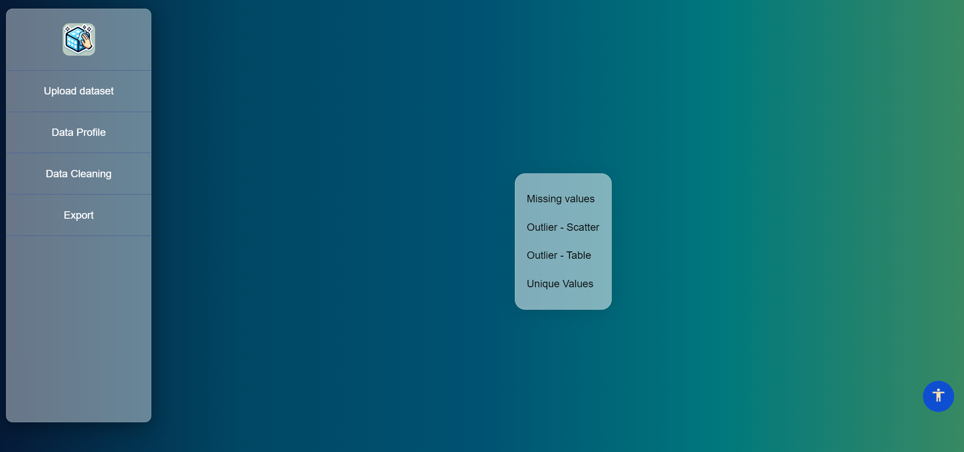

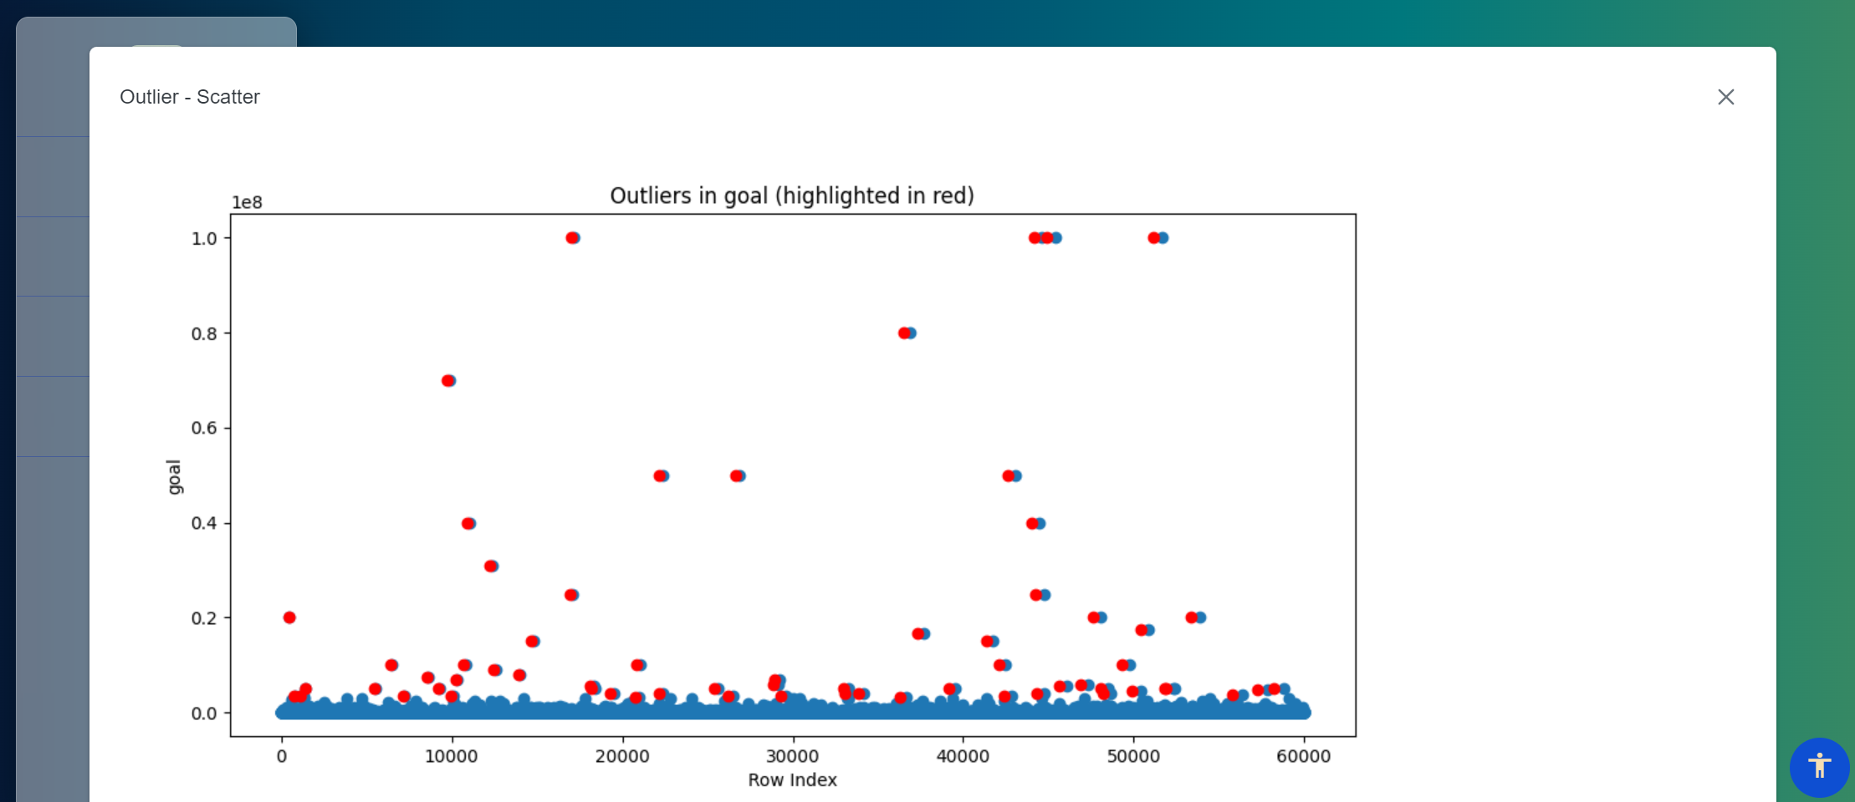

Data cleaning

In this page, end user will be able to click the button to initiate data cleaning process in the backend. For now, there is only this button on the page, and we are only removing duplicates from the dataset as the cleaning process. In upcoming releases, we will give the user the flexibility to choose which columns and which options of data cleaning they want the application to perform or keep as it as. This feature is referred to as ‘Column Specific Data Cleaning’.

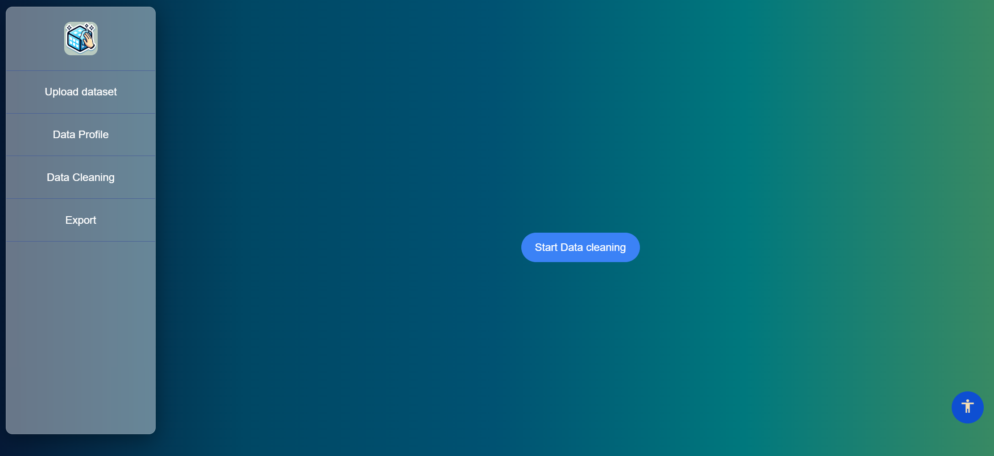

Export Data

In this page, user can enter the Job ID they received from the application after uploading the file and check status of it whether that file has been cleaned or not by clicking on the ‘Check Status’ button. If data cleaning process of that file is completed, they will be able to download the cleaned data file by exporting as CSV file.

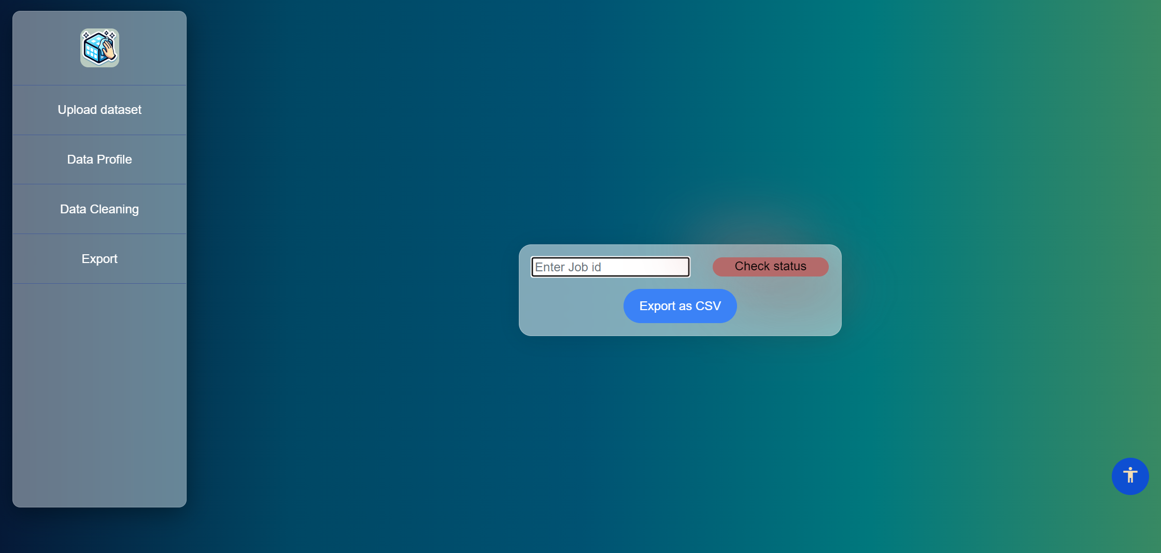

System Architecture

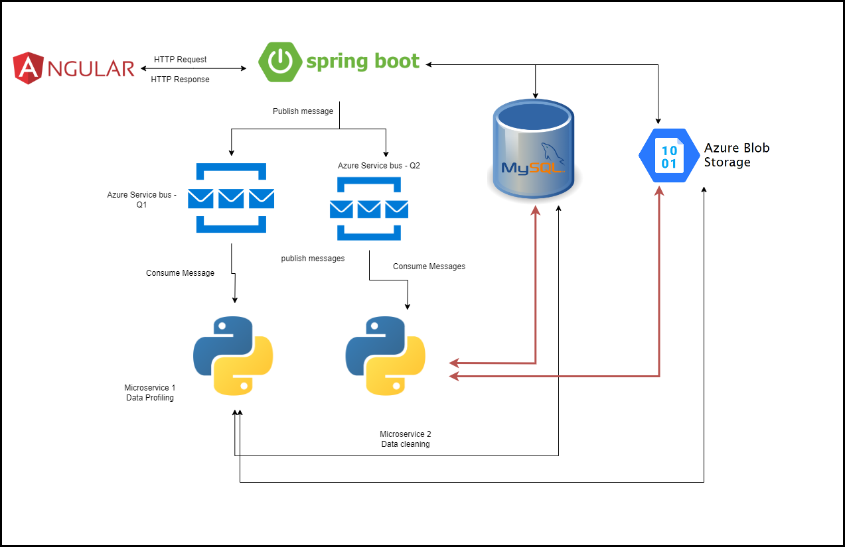

We are developing a modern web application using a stack that includes front-end technologies like Angular, Bootstrap, and Prime NG(framework) for the user interface and on the backend we are utilizing Java, Spring Boot, and Maven to build our APIs. Our data is stored in a MySQL database, and for file storage, we are using Azure Storage Account's blob storage. For data profiling and cleaning we've integrated Python into our application.

Users interact with the application using our Angular frontend interface. Angular app sends HTTP Request to spring boot API which can query database for any required information and put message into queue stating what it needs. Afterwards, python application takes the message from there, process and store data files in blob storage.

**Cloud Deployment**

Once system architecture was fixed, the basic application was also developed to be hosted. While hosting we faced several issues, and we had to change the architecture multiple times to ensure robust integrations between services.

To keep up with the learning curve, need for complex deployments, need of multiple environments to test code and limited cloud resources we decided to use AWS EC2 – Ubuntu server running tomcat server for spring boot application, angular applications and other python services are deployed as daemon services in the same server.

For database we are using AWS RDS service with MySQL engine. For messaging system we are taking advantage of Microsoft Azure service bus and for storing binary files we are using Microsoft Azure Storage Account Blob Storage.

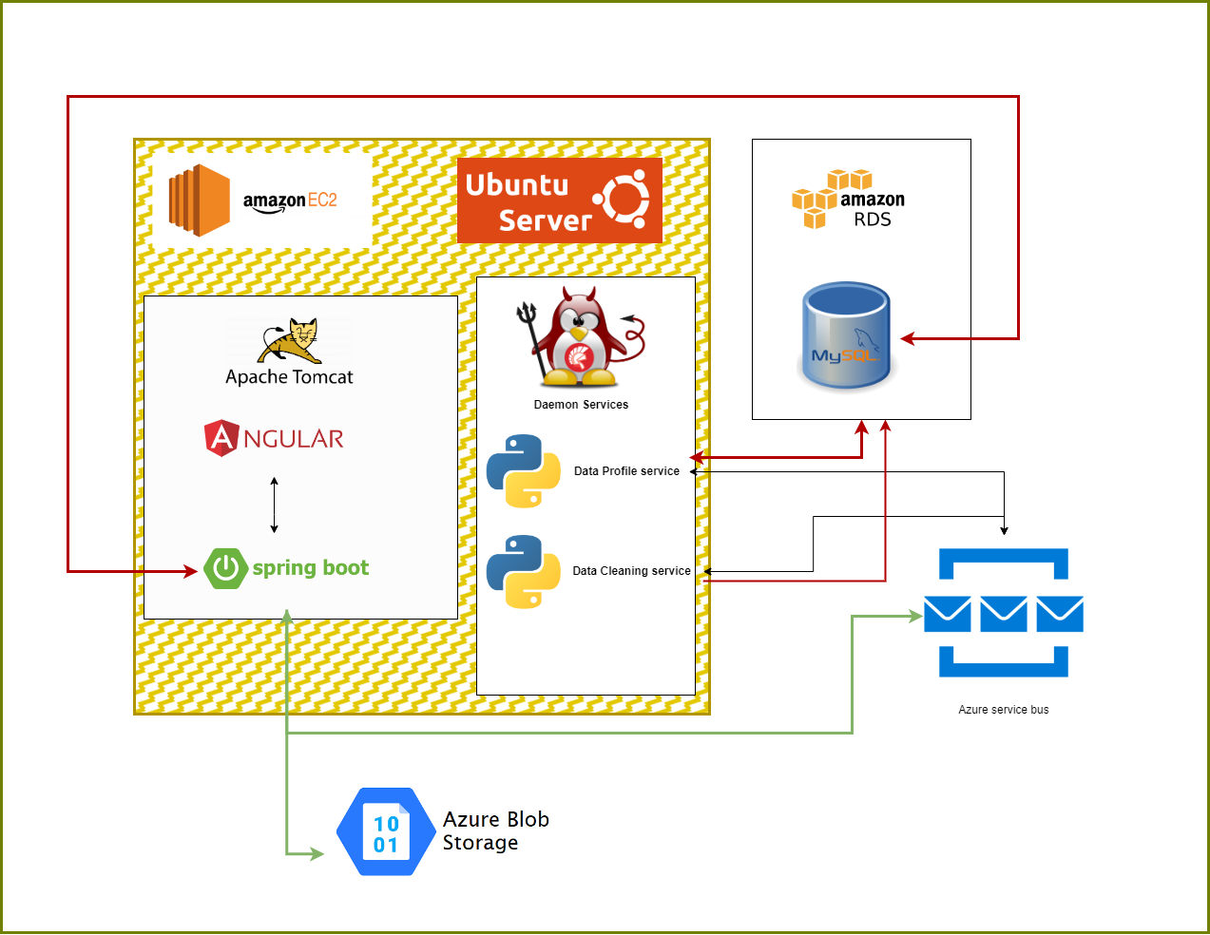

Fig: Cloud deployment diagram

Flow of our application:

**Data Upload** -

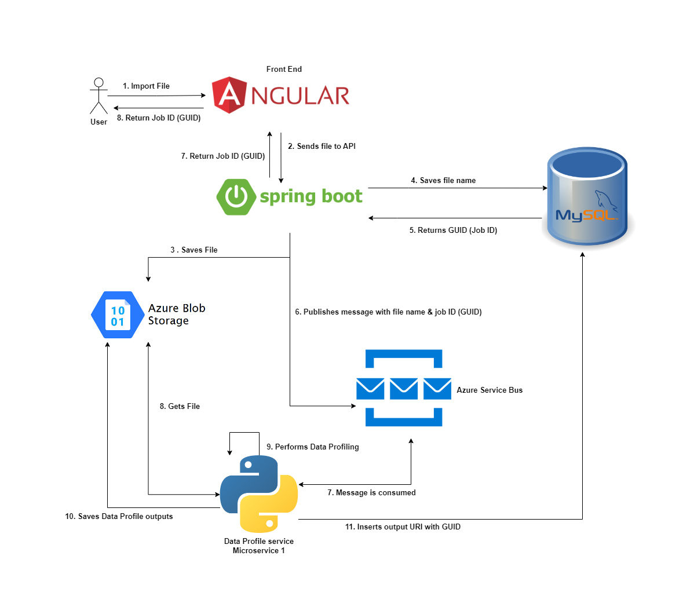

Fig: Technical flow diagram of Data Upload

This is the starting point for the user in our application. This flow starts by uploading dataset by end user in the angular application. From the angular app file is sent to spring boot API where file is saved in blob storage and name of the file will be stored in MySQL DB.

When file name is inserted into DB unique GUID is generated and returned to API. Unique GUID is Job ID and published to azure service bus in the form of message and same ID is returned to user. Python app running on backend will pick up the message from the queue and start processing it once data profile is done it save the output back into blob storage and puts URI in DB.

**Data Profile** -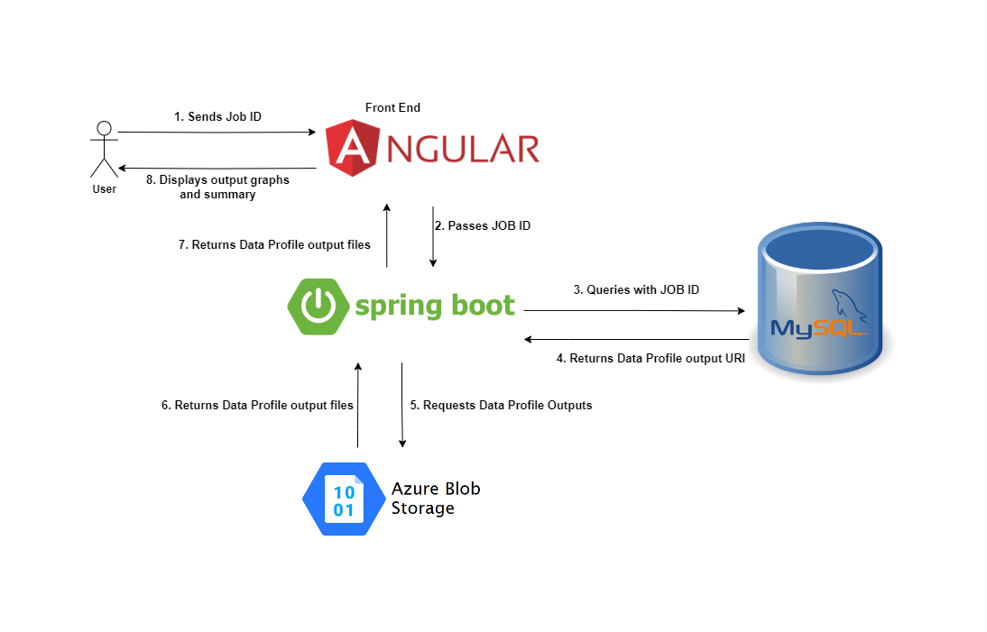

All the necessary operations for data profiles will be finished when the user uploads the data. So, when user wants to see the results of data profile they can just give the job ID they have into frontend. It will be passed to API from there database will be queried with the job id and return the URI of data profile output. Once the API gets URI it will fetch file from the blob storage and return it front end application where the data will be transformed into visualization.

**Data Cleaning**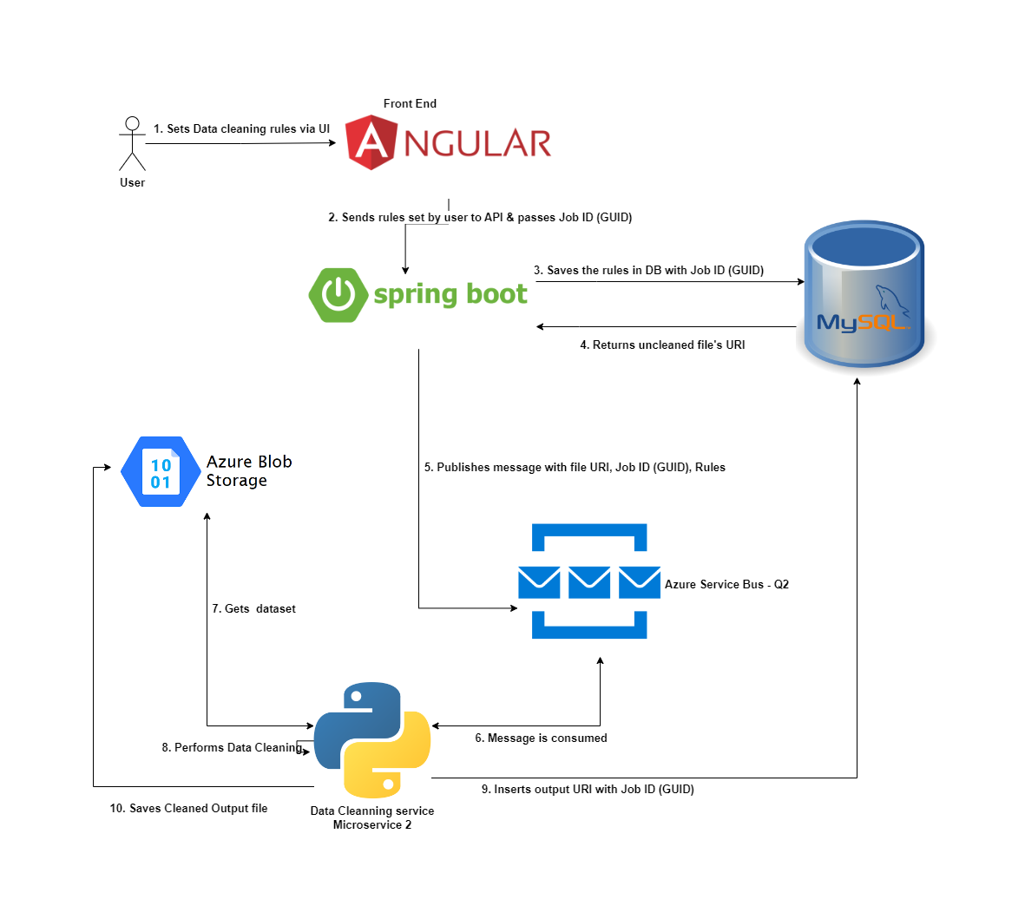

When user is satisfied with the data profile they can start cleaning data. They can set the rules from UI for data cleaning row by row, Angular collects all the rules and sends to spring boot API. From there, the rules are stored in database. This set of rules and job ID is published as message to queue. The python data cleaning service takes the message and starts working on it, gets the file from the blob, cleans it and saves it back to the blob. Finally, it saves the result data set URI in database.

**Export Data**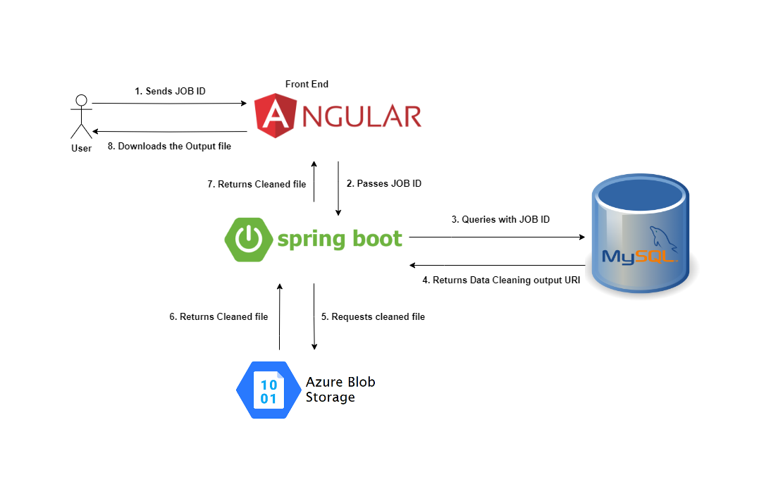

When user requests for clean dataset with their JOB ID, angular makes the HTTP request to spring boot application with job ID. API will get URI from database, fetch files from blobs and send to UI where user can download it.

**GIT Flow**

We use version control system to save, keep track of our teams progress and prevent from losing the changes. The version control system we are using for this project is GitHub. There are multiple flows we can follow to merge our changes into production but the one we choose is GIT flow.

We planned to do release after each sprint, and we needed multiple branches like development and QA to merge changes and test for each sprint which is not the case with GitHub flow where we use only two branches to track our changes that’s why we choose GIT flow.

(Hyett, 2022) &  (Phillips et al., 2011)

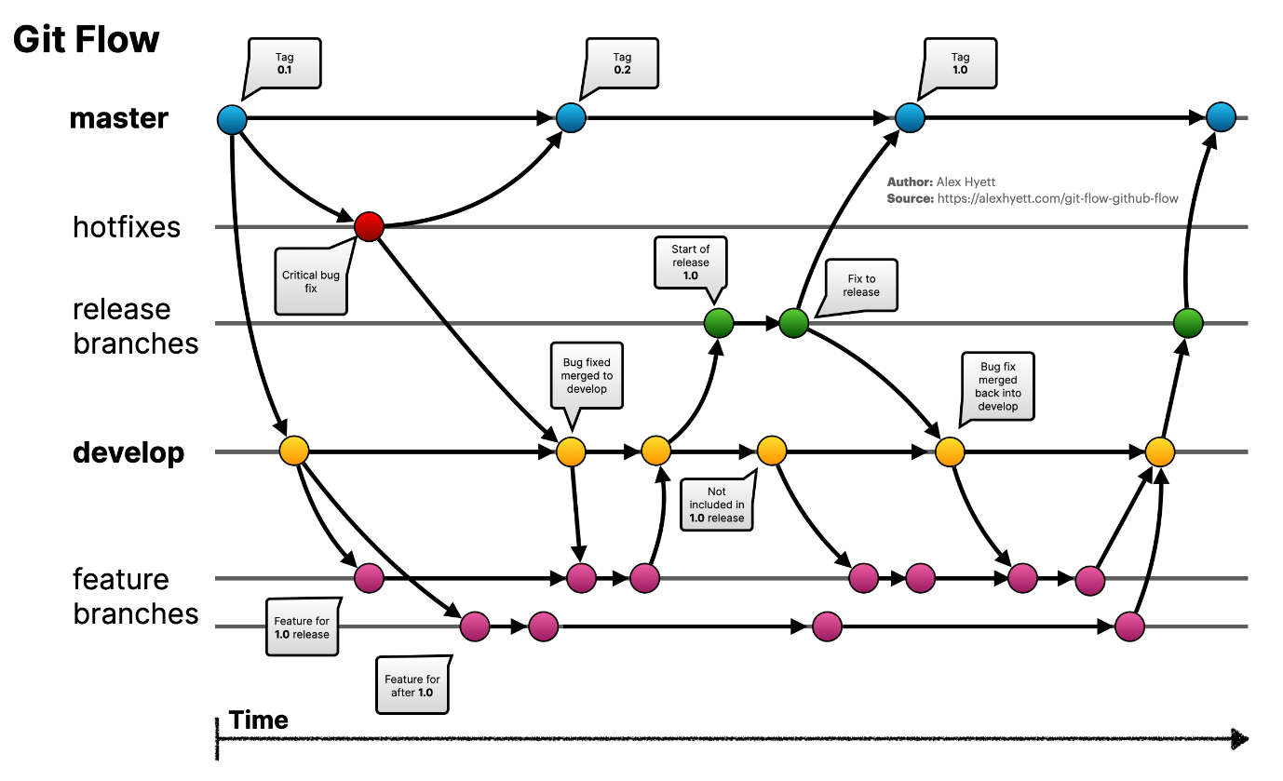

(Hyett, 2022)

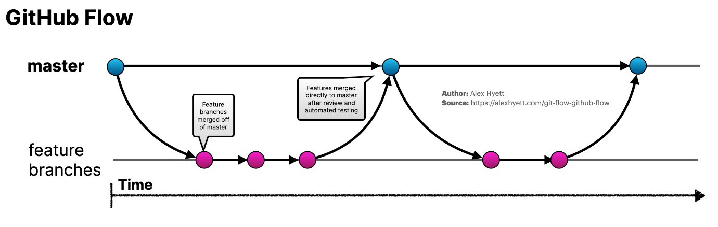

(Hyett, 2022)

We use GIT flow with some tweaks

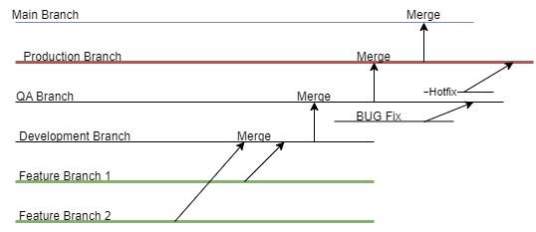

Feature Branches will be used by developers to push their code. Every story will have their own feature branch. Once the developer is happy with the feature branch, he can raise the pull request to team members to merge into develop branch. Our team has set the criteria that we need to have minimum of 2 approvals to merge. Once all the stories are closed for that sprint all the changes will be moved to QA where it will be deployed and tested.

We are using regression testing so far but plan to do automation. If branch has been signed off to merge, then it will be merged into production branch where I will be deployed, and quick testing will be done. And after the sprint is over with production code deployed it will be moved to main branch for backup just in case if anything goes wrong. This process is and will be followed throughout the project.

**Frontend Technologies**

We are using Angular to build our application frontend.

Modern UI

We've adapted our interface to the Glass morphism design trend to provide a modern and visually engaging user experience. This approach not only aligns with contemporary design aesthetics but also enhances user engagement and immersion, making information more appealing and accessible to our student users.

Accessible UI

In addition, we've prioritized inclusivity and an improved user experience for students with disabilities. There is a colour scheme toggle feature accessed through a user-shaped button, catering to those with visual impairments like colour blindness (7 Ways to Make Your Angular App More Accessible, 2019). Moreover, our plan is to incorporate audio descriptions to further facilitate navigation. When users hover their cursor over specific elements, such as buttons or links, they will receive audio feedback providing information about the function or purpose of that object.

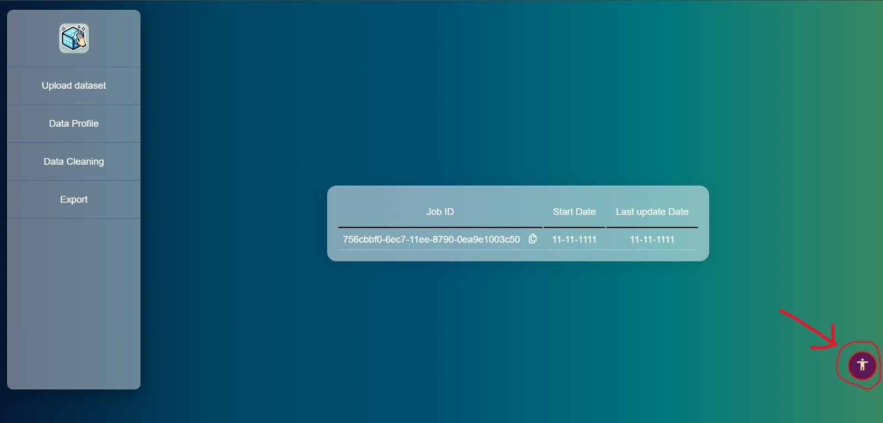

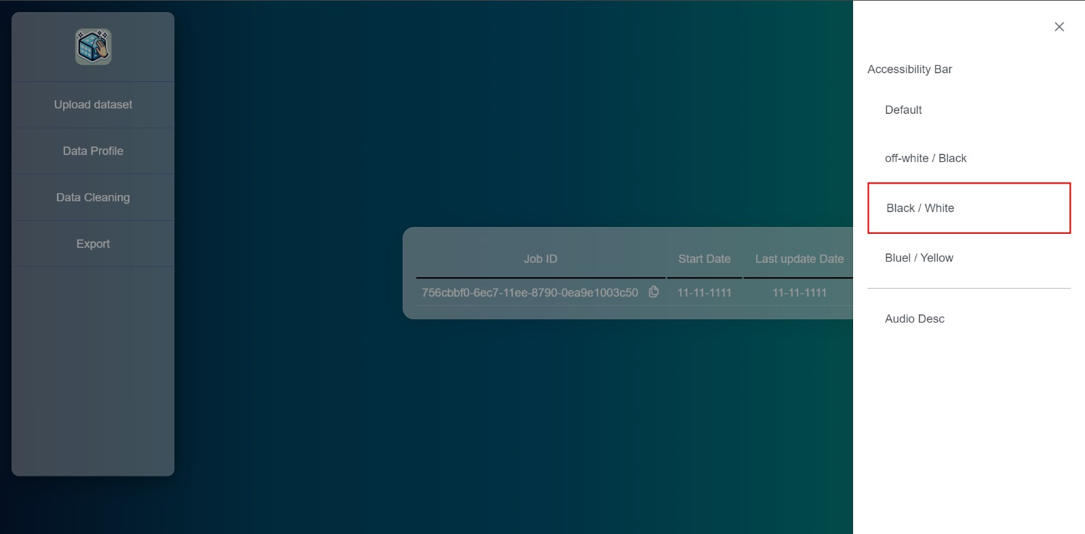

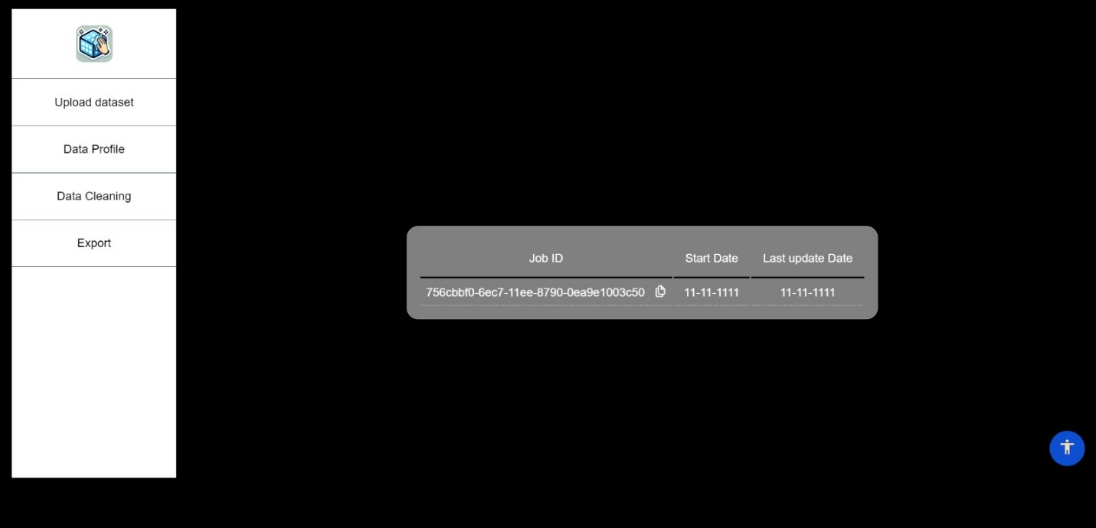

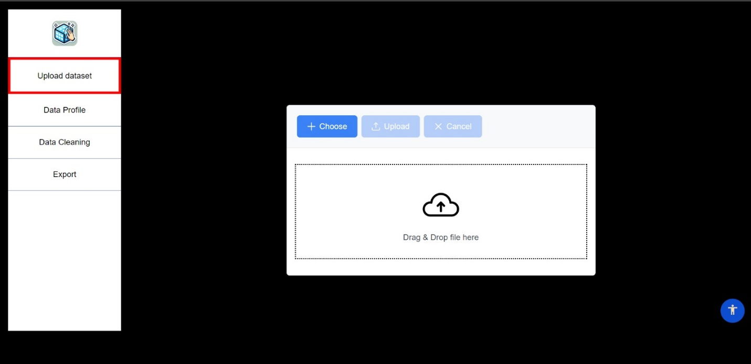

In our literature review on font types and sizes for accessibility, it was found that Times and Arial facilitated faster reading, while Georgia was perceived as the most attractive but less preferred overall (Bernard et al., 2002). Investigating fonts designed for digital content, researchers concluded that Georgia enhances online readability, emphasizing the importance of considering type size and other factors in font design (Boyarski et al., 1998). Exploring electronic display legibility, the study revealed a "letter superiority effect," favoring individual lowercase letters, and Verdana and Arial as the most legible fonts (Sheedy et al., 2005). For web reading, 12-point Arial was the most preferred and legible, with potential for serif fonts like Times New Roman to enhance comprehension at smaller sizes (L. Bernard & Mills, 2000). A study on fonts for dyslexic readers found that sans-serif, monospaced, and roman fonts improved reading, recommending Helvetica, Courier, Arial, Verdana, and Computer Modern Unicode, while discouraging Arial Italic (Rello & Baeza-Yates, 2013).

This paper emphasizes the continued use of Web Content Accessibility Guidelines (WCAG) as a foundational basis for creating accessible web interfaces and suggests combining user experience studies with these guidelines to ensure comprehensive accessibility (Examining the Perceptions of People with Disabilities on the Use of Accessibility Standards in Web Interface Design, n.d.). This thesis highlights the significance of aural interactive websites, which primarily rely on auditory input instead of visual content. It argues for the importance of considering aural interaction in web development and accessibility(Requirements for Aural Web Sites, n.d.). Audio is an accessible medium for individuals who are blind or visually impaired, as well as those with learning challenges or dyslexia. Audio formats offer an alternative for accessing written materials (Accessible Formats, n.d.). This paper offers guidelines for audio descriptions, including considerations like sentence tense, language simplicity, and avoiding slang. It aims to provide a comprehensive training manual for audio description (Snyder, 2020).

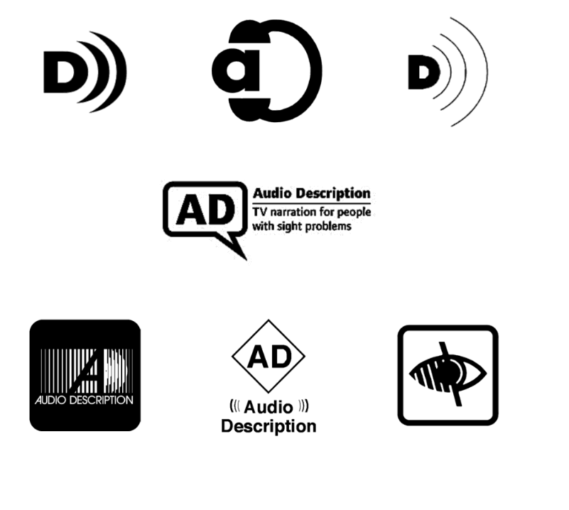

Fig: Icons for Audio Description (Snyder, 2020)

The research outlines solutions for making image memes more accessible. It introduces an automated method for converting image memes into alternative meme formats and an authoring interface for users to create accessible memes. The study involved 10 Twitter users with visual impairments who had a preference for alternative text memes (Gleason et al., 2019). The importance of addressing various accessibility challenges in game development was discussed in this paper, highlighting spatial sound technology's crucial role in enhancing the gaming experience for blind users by providing auditory cues for navigation. It also advocates for customizable font styles, readable fonts like Helvetica, Courier, Arial, Verdana, and Computer Modern Unicode, and customizable font sizes to improve on-screen readability for low-vision gamers. Additionally, it emphasizes the significance of customizable HUDs in enhancing the gaming experience for individuals with visual impairments and highlights the potential for smoother game development through these accessible features, even citing community-created mods in games like Skyrim as examples of HUD customization(Khaliq & Torre, 2019).

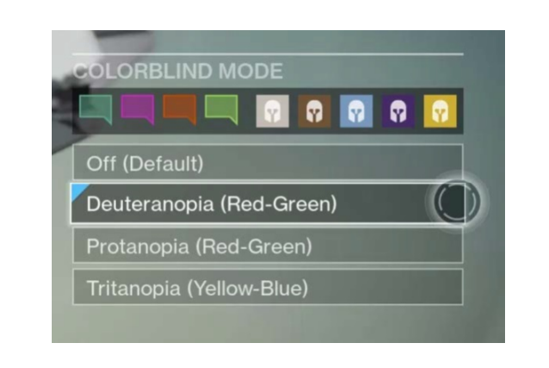

Fig: Colour themes for user with colour-blindness (Khaliq & Torre, 2019)

We have also researched the Web Content Accessibility Guidelines (WCAG) guidelines to address disability like visual impairments for web applications. While WCAG does not specify specific font sizes or font styles, it does provide recommendations related to text readability and audio descriptions. Here are the relevant WCAG guidelines-

1. Font Size and Text Readability:

* WCAG Success Criterion 1.4.4 - Resize Text: Ensure that text can be resized up to 200 percent without loss of content or functionality. Use relative units like percentages or ems for font sizes to allow users to adjust text size using browser features(“Understanding Success Criterion 1.4.4: Resize Text | WAI | W3C”).
* WCAG Success Criterion 1.4.5 - Images of Text: If images of text are used, ensure that the text is provided in a way that can be visually customized by the user without loss of content or functionality (“Understanding Success Criterion 1.4.5 | Understanding WCAG 2.0”).
* WCAG Success Criterion 1.4.10 - Reflow: Content should be designed so that when the page is zoomed or text size is increased, users do not have to scroll horizontally to read a line of text. This helps ensure that users can read content without losing context (“Understanding Success Criterion 1.4.10: Reflow”).
* WCAG Success Criterion 1.4.11- Non-text Contrast: This guideline focuses on ensuring that user interface components and graphical objects have sufficient contrast. While it doesn't specify font size directly, it relates to the readability of text against its background (“Understanding Success Criterion 1.4.11: Non-Text Contrast”).
* WCAG Success Criterion 1.4.12 - Text Spacing: Ensure that users can adjust the spacing of text without loss of content or functionality. Some users with visual impairments may need to adjust text spacing for readability (“Understanding Success Criterion 1.4.12: Text Spacing”).

1. Font Style:

WCAG does not have specific guidelines related to font style. However, it emphasizes the use of clear and legible fonts and sufficient contrast between text and background to ensure readability.

1. Audio Descriptions:

WCAG provides guidelines for audio descriptions in video content to make it accessible to individuals with visual impairments.

* + WCAG Success Criterion 1.2.3 - Audio Description or Media Alternative (Pre-recorded): For prerecorded video content, provide an audio description of the visual content to make it accessible to individuals who are blind or have low vision. This involves describing key visual information that is not otherwise conveyed through the main audio track (“Understanding Success Criterion 1.2.3: Audio Description or Media Alternative (Prerecorded) | WAI | W3C”).
  + WCAG Success Criterion 1.2.5 - Audio Description (Prerecorded): For prerecorded video content that includes audio descriptions, ensure that the audio description can be turned on or off by the user, so they have control over the additional audio information (“Understanding Success Criterion 1.2.5: Audio Description (Prerecorded) | WAI | W3C”).

Screen Mock-ups

We have used Lucid Chart to create the initial mock-ups or medium fidelity prototypes of five pages. The ‘Data Preview/Visualization’ page have not been implemented yet; its execution is planned for the next release.

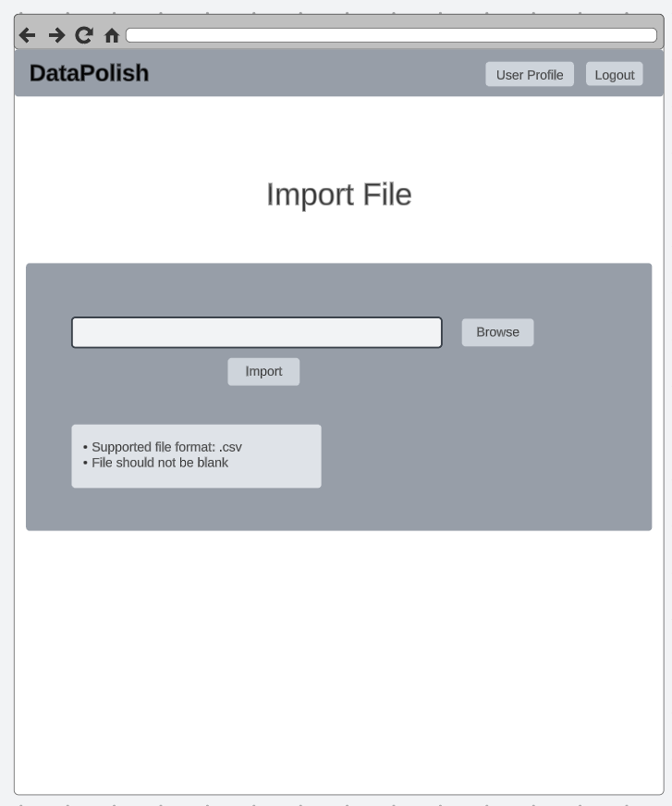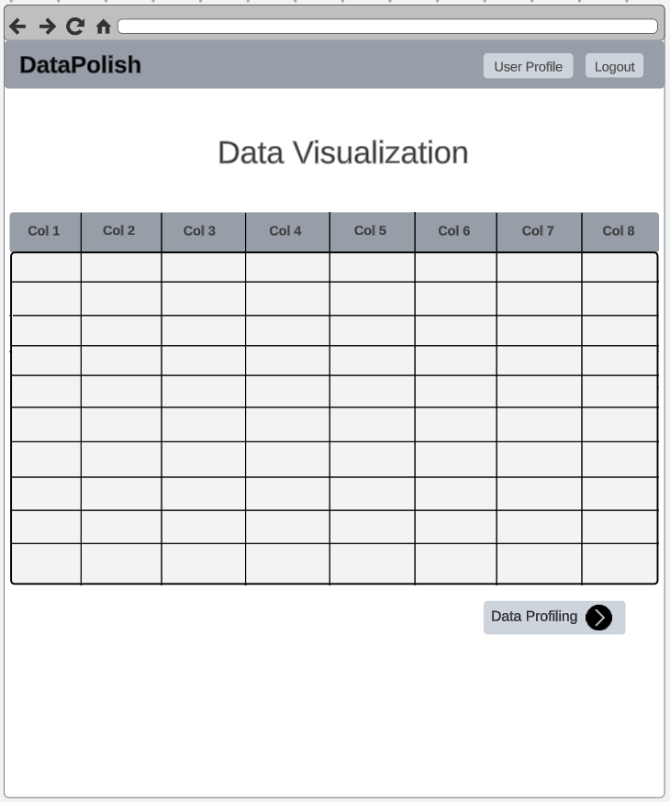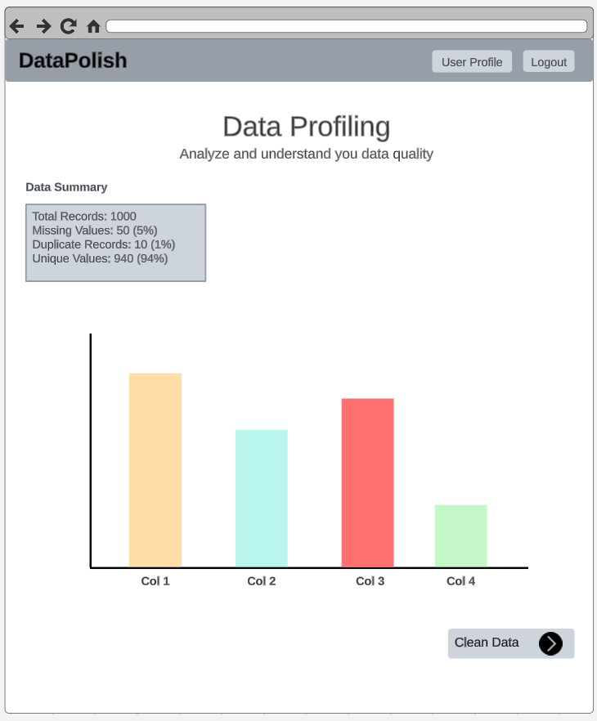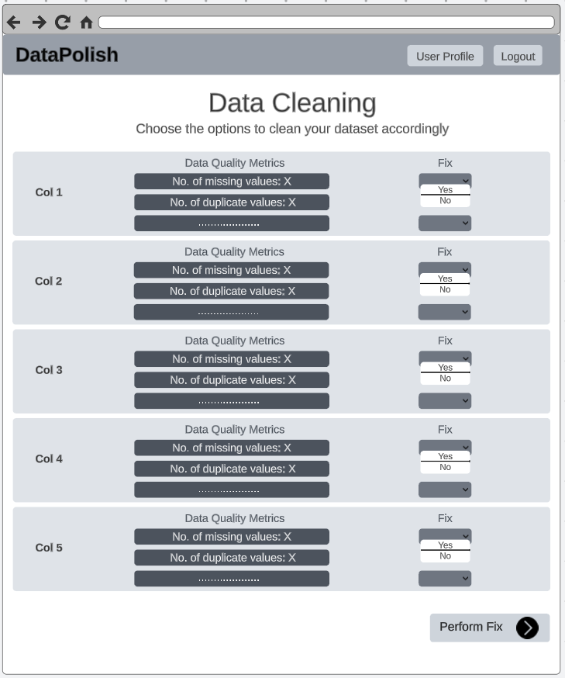

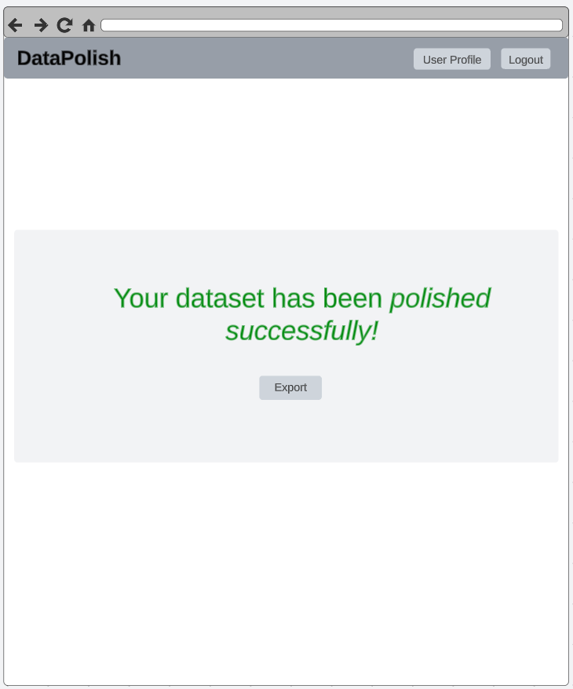

**Angular**

For front-end, we used Angular to develop our application because of following reasons:

Angular is a full-fledged framework which give a structured ways to build web applications to maintain code consistency. Angular modular and component-based architecture can allow us to build applications by breaking them into smaller components. This modularity enhances code maintainability and reusability.

Angular also has two-way data binding, which simplifies the synchronization of data between the user interface and application logic. Angular's built-in dependency injection system makes it easier to manage and share dependencies across components and services. It promotes a more maintainable and testable codebase. It also integrates RxJS, a library for handling asynchronous and event-driven operations. This makes it easier to manage data streams, handle HTTP requests, and perform real-time updates. it also has a very support of unit testing framework. (What Is Angular? | Simplilearn, n.d.)

Back-end technologies we are using in our application are follows:

|  |  |
| --- | --- |
| Backend API | Java – Spring Boot |
| Relational DB Engine | MySQL |
| Relational DB Hosting | AWS RDS |
| File Storage | Azure storage Account blob storage |
| Messaging system | Azure Service bus queues |
| Data profiling & cleaning | Python microservices |
| API Hosting technology | Tomcat server |
| Python hosting technology | Linux Daemon service |
| Api and python hosting server | AWS EC2 |
| Server operating System | Ubuntu server |

**Backend API – Java Spring boot**

Entire application relies on backend APIs. We choose spring boot because everyone from our team has some basic understanding of java. Spring Boot has a large and active community. This means that we can find a lots of resources, tutorials, and libraries to help with project development. Spring Boot provides built-in security features, including support for OAuth, JWT, and other authentication and authorization mechanisms. This makes it easier to secure our API.

Spring Boot makes it easy to write unit tests for our APIs and mock certain functions with injecting dependency. Spring Boot is good for building microservices. Our application is almost entirely runs on microservices which are small, independent services that can be deployed and scaled individually. It provides features like embedded containers, which simplify the deployment and scaling of microservices (Kushnir, 2021).

**Relational DB and MYSQL**

We decided to use relational Database because it enforces a structured schema, which ensures data consistency and integrity. They have a proven track record of stability and reliability. Relational databases are very good at handling complex queries. Initially we choose Oracle DB but later due to the limitation in cloud services available, we switched to MySQL Engine which also have all the necessary features we needed. (*What Is a Relational Database?*, 2020)

**AWS RDS**

AWS RDS is a fully Managed Service, takes care of many of the routine database management tasks, such as patching, backups. This allows to focus on application's data and functionality rather than database administration. AWS has a large and active community and offers robust support options, including documentation and forums. (AWS, 2019)

**File Storage - Azure storage Account blob storage**

It is a versatile and scalable solution for storing large amounts of unstructured data. In order to prevent vendor lock-in we went for Azure rather than AWS S3 bucket (cloudflare, 2021). A multi-cloud strategy is an approach where an organization uses cloud services and resources from multiple cloud providers simultaneously, with the goal of preventing vendor lock-in, increasing redundancy and reliability, and taking advantage of the unique features and pricing structures of different cloud providers.

**Service BUS**

Azure Service Bus offers a reliable and durable messaging system that ensures messages are delivered even in the face of failures, making it a robust choice for building applications that require guaranteed message delivery. Again, to prevent vendor lock-in we use azure over AWS Messaging (cloudflare, 2021).

**Data profiling & cleaning - Python microservice**

We are using python microservices because of the following advantages:

Python has a vast ecosystem of open-source libraries specifically designed for data cleaning and manipulation, such as Pandas, NumPy, and SciPy.

Python's syntax is known for its readability and expressiveness, making it easy to write code that clearly conveys data cleaning tasks. Python offers libraries like Matplotlib and Seaborn for data visualization. This is useful for gaining insights into the data during the cleaning process.

**API Hosting Technology - Tomcat server**

While Spring Boot applications can be packaged as standalone JAR files, Tomcat can also deploy traditional WAR (Web Application Archive) files, which is a common format for Java web applications. This flexibility allowed us to choose the deployment method that best suited our needs.

Tomcat can be used in conjunction with a reverse proxy server like Apache HTTP Server or Nginx to handle tasks like load balancing, SSL termination, and serving static content. This setup provides additional capabilities and enhances security.

Spring Boot simplifies the deployment of the application on Tomcat. Spring Boot's embedded Tomcat configuration means we do not need to set up an external Tomcat server; everything is bundled into the Spring Boot application. It is known for its lightweight design and efficiency.

**Python hosting technology - Linux Daemon service**

Hosting Python microservices as Linux daemons, or background services, offers several advantages, making it a practical choice for running microservices in a production environment. Here are some reasons why chose to host Python microservices as Linux daemons:

Linux daemons run in the background, independent of user sessions. This allows our microservices to execute continuously and independently of user interactions, making them suitable for long running and non-interactive tasks. Linux daemons benefit from the stability and robustness of the Linux operating system. They can be configured to restart automatically in case of failures, helping ensure high availability. Running microservices as daemons can be resource-efficient. We can control the resource allocation (CPU, memory, etc.) to optimize performance and prevent resource contention with other processes.

Daemons can be configured with limited permissions and security restrictions, reducing the attack.

**AWS EC2**

Here we simply went for low-cost virtual machine with high reliability on a pay-as-you-go basis. Since we need complex deployments, we were not able to deploy our services on serverless architecture.

EC2 provided us more control over the environment. we have direct access to the underlying operating system, allowing us to configure and optimize it to our specific needs. Cost effective for Resource Intensive workload like out data cleaning, deployments of microservices architectures and Custom Networking

**UBUNTU server**

We choose ubuntu server as OS because of its Reliability , Long Term Support (LTS), Security and ease of use since it’s a Debian flavour.

**Data** :

We are taking test datasets from Kaggle that are at least over 60,000 rows and more than 13 columns. But less than 30. Currently we support only CSV file format for data sets. when user is uploading. We store them in azure storage account blog storage.

**Evaluation**

Success, for our team, means enabling our student users to easily import, visualise, clean, and export their data. We recognise that data cleaning can be time-consuming and aim to streamline this process for our users. Our success will be measured through interview feedback, and based on the prototype feedback we have received, we have identified specific guidelines and metrics we aim to achieve. For instance, we strive to provide statistical information, allow for Excel importation, improve the UI, and add a user association feature to enhance user satisfaction and evaluate our system’s success.

**VI. Conclusion**

Our team employs an agile with scrum methodology for the management of the project (Hu, Yuan, & Zhang, 2009). Agile with scrum was chosen as it offers flexibility, adaptability and is a more collaborative approach when compared to traditional methodologies such as waterfall. Waterfall has documented limitations including poor visibility, can cause a lack of communication between stakeholders and is bad at handling unstructured code (Gabaorv, et al, 2021).

The team is composed of two advanced software development (ASD) MSc students and three data science (DS) MSc students. ASD members work on the backend and frontend of the product while DS members work on data cleaning functionality and the data profiling dashboard. Below is a breakdown of the team roles

|  |  |  |  |  |
| --- | --- | --- | --- | --- |
| Name | Student Number | Development role | PM Roles | Testing roles |
| Sean McCrossan | [D22124413](mailto:d22124413@mytudublin.ie) | Floater between data cleaning and profiling | Developer | Tester |
| Naveen Maheswaran | D22124491 | Backend developer | Developer | Tester |
| Oluwatobi Omole | D22125039 | Data cleaning python developer | Developer | Tester |
| Nikodem Adamski | C18415776 | Data profiling python and JavaScript developer | Scrum master/Project manager | Evaluator |
| Umama Sumlin Tasnuva | D22124465 | Frontend developer | Developer | Evaluator |
|  |  |  | *Roles rotate every sprint | |

A sprint cycle lasts one week, and a daily scrum (15-30 minute) meeting is conducted to report on progress and challenges from each team member. Jira, GitHub and Slack are used to manage the project along with requirement spreadsheets. GitHub is the project repository and is used to track pull requests and commits. Jira is used to create epics, stories and issues which are the tasks that are assigned at the sprint kick off meeting every Monday and progress is tracked throughout the week in the daily scrum. Slack is the teams internal messaging tool. GitHub, Jira and slack are all linked to each other.

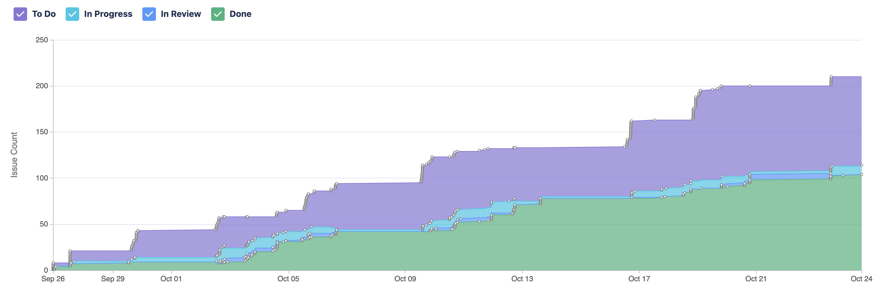

Figure 1 Jira issue cumulative report

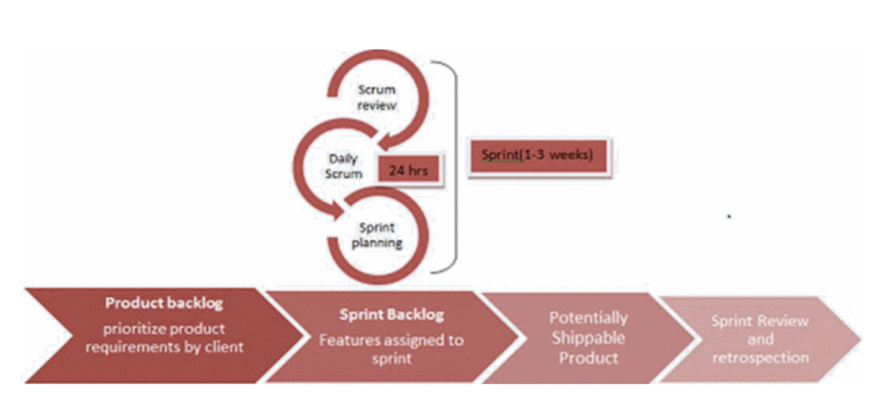

Figure 2 Sprint cycle (Srivastava, Bhardwaj and Saraswat, 2017)

The development of the project is scheduled to stop on the 1st of December to allow sufficient time for testing, evaluation and improvements before the final release.

|  |  |  |  |
| --- | --- | --- | --- |
| Week No | Week | Features to be included | Comments |
| 2 | 25th - 29th Sep | Data Import | Start of work and research |
| 3 | 2nd - 6th Oct | Data Quality checks and export of data | Data quality check module created, not all functions made it to final |
| 4 | 9th-13th Oct | Data cleaning | Data cleaning module created, only dataset wide cleaning up taken |
| 5 | 16th - 20th Oct | Data Profiling images | D3 dashboard scrapped for this release, only static pyplots |
| 6 | 23rd - 27th Oct | UI improvements and stability | Worked on stability |
| 7 | 30th - 3rd Nov | Data Preview and Data Import V2 | Data preview to be finished |
| 8 | 6th - 10th Nov | Data profile dashboard and data cleaning column level | D3 dashboard and column level cleaning |
| 9 | 13th - 17th Nov | Create new columns, Dimension reduction | Not finalised but more complex features to be released |
| 10 | 20th - 24th Nov | Statistical analysis data profile visuals and annotation | More complex charts in data profiling |
| 11 | 27th - 1st Dec | Multiple file imports | Allow users to upload multiple files |
| 12 | 4th - 8th Dec | Testing and evaluation | Small improvements or possible new functionality (code freeze) |
| 13 | 11th - 15th Dec | Testing and evaluation | Stop all functionality (code freeze) |
| 14 | 18th - 22nd Dec | Final report writing and presentation | Product stable and general release. |

## Team meetings:

The meeting schedule follows the agile scrum methodology (Srivastava, Bhardwaj and Saraswat, 2017). Daily scrum meetings are 30 minutes that occur online every Tuesday, Wednesday and Thursday. Each team member answers the following questions:

1. What did you do yesterday?
2. What are you planning to do today?
3. Are there any blockers impacting your progress?

On these meetings team members are encouraged to share ideas or research they have completed, giving the team visibility and raise other issues in front of the team. The team has a sprint planning meeting every Monday with the objective of assigning tasks to team members to complete during the sprint. On Friday the team has two in person meeting post the lectures. On the sprint review meetings, we discuss how the current sprint went and what should the goal of the following sprint should be and then we organize the project backlog of Jira’s. On the retrospective we anonymously list, to ensure an open dialogue, what went well, what did not go well and what we should start doing, each of these points is then discussed by the team.

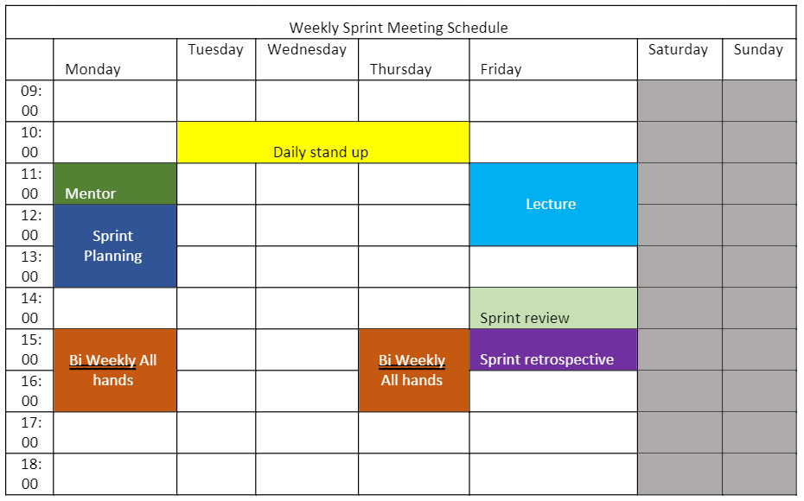

Figure 3 Team meeting schedule (Bi Weekly all hands has been removed)

More specific meetings are scheduled on an ad-hoc basis through huddle on slack between relevant team members. Every few weeks the team will organize a design workshop where we will meet in person on campus to design and prioritize features for the product based on the information gathered from research, competitor analysis and user feedback.

Big decisions are made by consensus within the team unless there are instances where expert decision making is required. The role of scrum master/project manager is rotated weekly.

# Challenges:

## Integration of parts into one cohesive product

To mitigate issues of deployment of the final product, as reported by previous years teams, the team’s early objective was to deploy a minimal viable product (MVP) by week 4. While we were able to show each of the product’s components by this time and have some integration, we did fail in delivering a full stable, which has delayed our planned user feedback sessions.

This project has been a steep learning curve in the overall tech stack, and we have had to pivot early to try and achieve the MVP milestone. For example, we were unable to include the column specific cleaning functions created or the D3 dashboard in this release due to the integration issues. We switched from a python flask API backend to a microservice. Members of the data science team that were building the python functionality had to watch tutorials on YouTube on how to build a flask API as before this project the DS team were familiar with only python scripts in Jupyter notebooks.

@Naveen More on the challenges from your side.

## How to differentiate our product from competitors given limited time

Data cleaning as a product has been around for a long time with plenty of established competitors that offer a wide variety of functionality. During our research we have identified at least ten of them. For each of the competitor analysis we looked at key features, the pros and cons of the product and how we would differentiate. One of the key takeaways that we got from this was that we should build best in class visualizations. Those

## How to incorporate more complex data science techniques

Data cleaning itself is data science but while it is probably the most time consuming, most of it is also very basic and not too complex. The team have been working on finding the balance between keeping the product simple for the user but to also include some more advanced data science techniques to make this a worthy project of a data science masters. Machine or deep learning algorithms don’t really fit into the scope of data cleaning but advanced data science techniques such as PCA for dimension reduction do and we need to try and incorporate these techniques into the product.

# Tmeline

After 6 weeks of working together we have a better idea on estimating time for tasks.

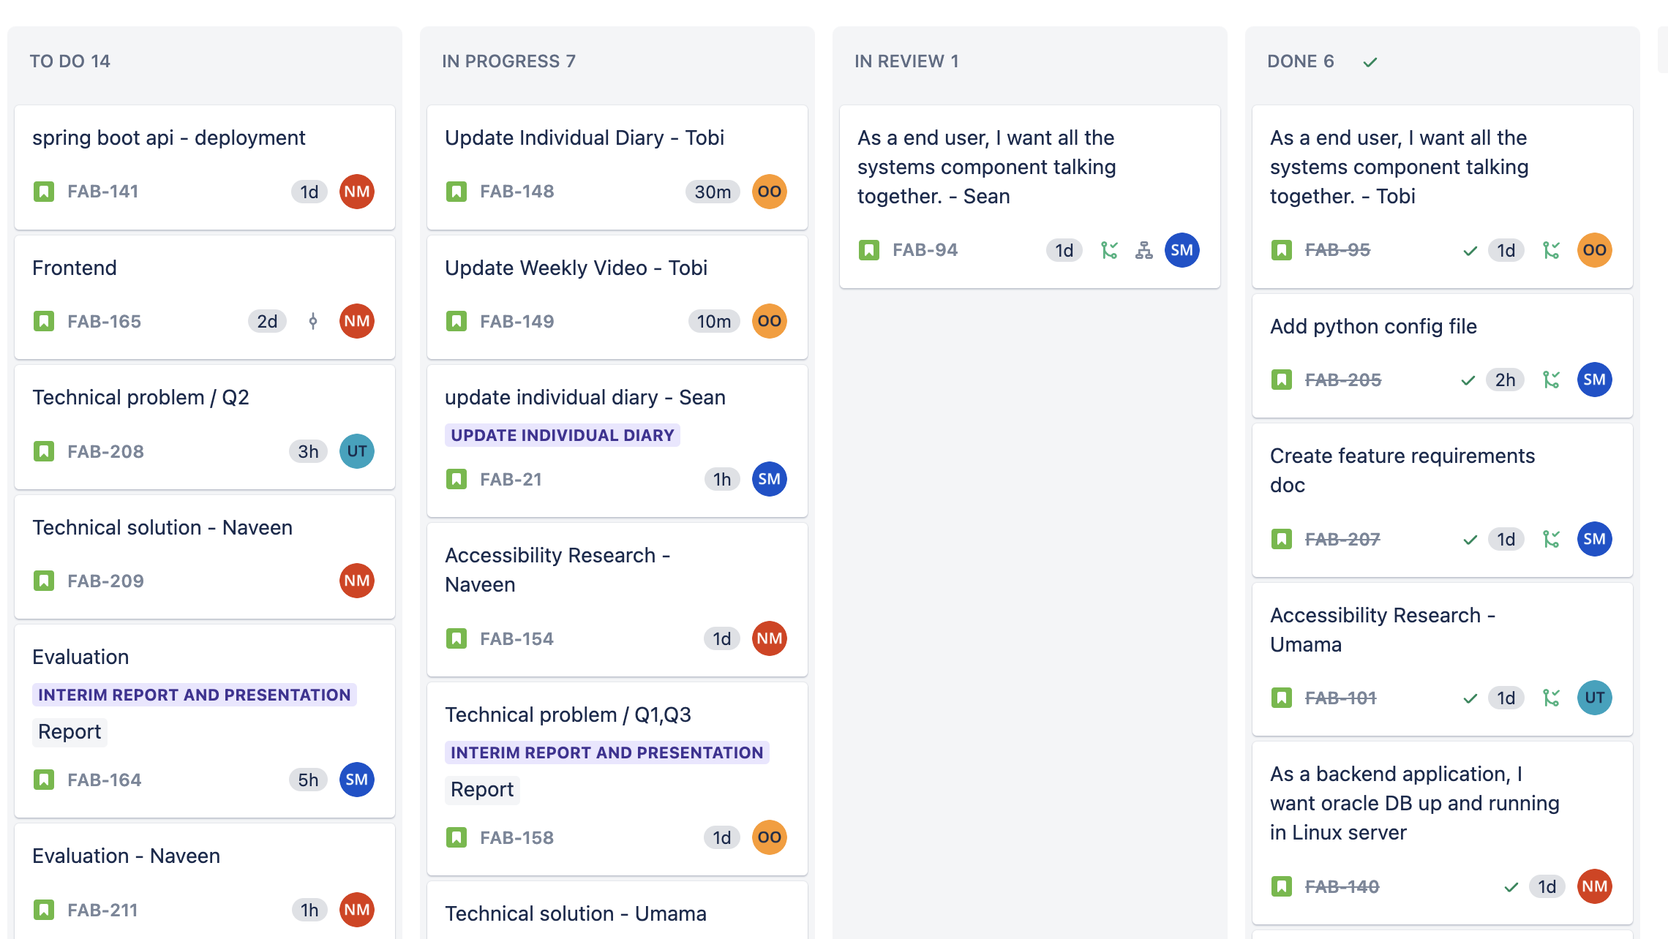

Figure 4 screenshot of Jira board

The below Gnatt chart shows the timeline for the entire project organised by tasks required for MVP, Beta, Alpha and general release. For the next two weeks to team will focus on the two big features needed, basic column cleaning and an interactive data profiling dashboard. Once these have been completed the team will then focus on building the more advanced data science functionality such as dimension reduction, creating new columns and statistical profiling of the user data. New features may be included or removed as the project continues pending user feedback from the MVP and Beta release. The last weeks will be focussed on a stable general release and collecting user feedback. A code freeze on new functionality will be in place from December first, focussing instead on stability and testing.

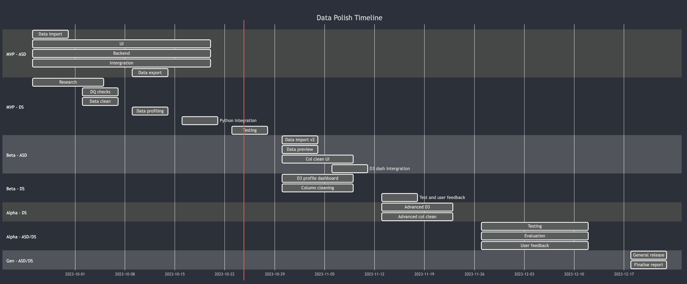

Figure 5 Gnatt chart for project completion

References

Accessible formats. (n.d.). Sight Scotland. <https://sightscotland.org.uk/articles/information-and-advice/accessible-formats>

Angular base href not showing up in URL. (n.d.). Stack Overflow. Retrieved October 20, 2023, from <https://stackoverflow.com/a/60021179>

AWS. (2019). Amazon Relational Database Service (RDS) – AWS. Amazon Web Services, Inc. https://aws.amazon.com/rds/

Boyarski, D., Neuwirth, C., Forlizzi, J., & Regli, S. H. (1998). A study of fonts designed for screen display. Proceedings of the SIGCHI Conference on Human Factors in Computing Systems - CHI ’98. https://doi.org/10.1145/274644.274658

Chu, X., Ilyas, I. F., Krishnan, S., & Wang, J. (2016, June). Data cleaning: Overview and emerging challenges. In *Proceedings of the 2016 international conference on management of data* (pp. 2201-2206).

cloudflare. (2021). What Is Vendor Lock-In? | Vendor Lock-In and Cloud Computing | Cloudflare. Cloudflare. https://www.cloudflare.com/learning/cloud/what-is-vendor-lock-in/

Elmuti, D., & Kathawala, Y. (2001). An overview of strategic alliances. *Management decision*, *39*(3), 205-218.

Epoch Converter. (2010). Epochconverter.com. https://www.epochconverter.com/

Examining the Perceptions of People with Disabilities on the Use of Accessibility Standards in Web Interface Design. (n.d.). Ieeexplore.ieee.org. Retrieved October 21, 2023, from https://ieeexplore.ieee.org/abstract/document/9274056

Gaborova, M., Karuović, D., Kavalić, M., Radosav, D., Milosavljevć, D., Stanisaljev, S., & Bushati, J. (2021). Comparative analysis of agile and traditional methodologies in IT project management. *Journal of Applied Technical and Educational Sciences (jATES)*, 11(4), 1-24. <https://doi.org/10.24368/jates.v11i4.279>

Gleason, C., Pavel, A., Liu, X., Carrington, P., Chilton, L. B., & Bigham, J. P. (2019). Making Memes Accessible. The 21st International ACM SIGACCESS Conference on Computers and Accessibility. <https://doi.org/10.1145/3308561.3353792>

Gudelli, A. (2023, February 8). WARNING in budgets, maximum exceeded for initial Angular error fix. Angular Wiki. <https://www.angularjswiki.com/angular/warning-in-budgets-maximum-exceeded-for-initial-angular-error/>

Hu, Z., Yuan, Q., & Zhang, X. (2009). Research on Agile Project Management with Scrum method. 2009 IITA International Conference on Services Science, Management and Engineering.

Hyett, A. (2022, November 10). Git Flow vs GitHub Flow. Alex Hyett. https://www.alexhyett.com/git-flow-github-flow/

Bernard, M., Lida, B., Riley, S., Hackler, T., & Janzen, K. (2002). A Comparison of Popular Online Fonts: Which Size and Type is Best? Issue 1 | Past Issues | A-Z List, 4. <https://citeseerx.ist.psu.edu/document?repid=rep1&type=pdf&doi=21a32bc134881ef07726c0e45e3d01923418f14a>

Images not loading from assets folder in Angular. (n.d.). Material Design for Bootstrap. Retrieved October 20, 2023, from <https://mdbootstrap.com/support/angular/images-not-loading-from-assets-folder-in-angular/#:~:text=Dear%20%40mani12->

Jain, N. (2021). Survey versus interviews: Comparing data collection tools for exploratory research. *The Qualitative Report*, *26*(2), 541-554.

Khaliq, I., & Torre, I. D. (2019). A Study on Accessibility in Games for the Visually Impaired. Proceedings of the 5th EAI International Conference on Smart Objects and Technologies for Social Good. <https://doi.org/10.1145/3342428.3342682>

Kushnir, Anastasia. “Pros and Cons of Using Spring Boot.” Insights, 4 July 2021, bambooagile.eu/insights/pros-and-cons-of-using-spring-boot/.

L. Bernard, M., & Mills, M. (2000, July). So, What Size and Type of Font Should I Use on My Website?. https://www.researchgate.net/publication/265740857_So_What_Size_and_Type_of_Font_Should_I_Use_on_My_Website

Phillips, S., Sillito, J., & Walker, R. (2011). Branching and merging. Proceedings of the 4th International Workshop on Cooperative and Human Aspects of Software Engineering. https://doi.org/10.1145/1984642.1984645

Rahm, E., & Do, H. H. (2000). Data cleaning: Problems and current approaches. *IEEE Data Eng. Bull.*, *23*(4), 3-13.

Rello, L., & Baeza-Yates, R. (2013). Good fonts for dyslexia. Proceedings of the 15th International ACM SIGACCESS Conference on Computers and Accessibility - ASSETS ’13, 14. <https://doi.org/10.1145/2513383.2513447>

Sheedy, J. E., Subbaram, M. V., Zimmerman, A. B., & Hayes, J. R. (2005). Text Legibility and the Letter Superiority Effect. Human Factors: The Journal of the Human Factors and Ergonomics Society, 47(4), 797–815. https://doi.org/10.1518/001872005775570998

Srivastava, S. Bhardwaj and S. Saraswat, "SCRUM model for agile methodology," 2017 International Conference on Computing, Communication and Automation (ICCCA), Greater Noida, India, 2017, pp. 864-869, doi: 10.1109/CCAA.2017.8229928.

Snyder, J. (2020). The Visual Made Verbal: A Comprehensive Training Manual and Guide to the History and Applications of Audio Description. In Google Books. Æ Academic Publishing. <https://books.google.ie/books?id=WHorEAAAQBAJ&lpg=PR9&ots=kI221IhXXU&dq=accessibility%20website%20audio&lr&pg=PR17#v=onepage&q=accessibility%20website%20audio&f=false>

[ubuntu] Error while using apt-get install [Archive] - Ubuntu Forums. (n.d.). Ubuntuforums.org. Retrieved October 20, 2023, from <https://ubuntuforums.org/archive/index.php/t-2151671.html>

“Understanding Success Criterion 1.2.3: Audio Description or Media Alternative (Prerecorded) | WAI | W3C.” Www.w3.org, [www.w3.org/WAI/WCAG21/Understanding/audio-description-or-media-alternative-prerecorded.html. Accessed 24 Oct. 2023](http://www.w3.org/WAI/WCAG21/Understanding/audio-description-or-media-alternative-prerecorded.html.%20Accessed%2024%20Oct.%202023).

“Understanding Success Criterion 1.2.5: Audio Description (Prerecorded) | WAI | W3C.” Www.w3.org, www.w3.org/WAI/WCAG21/Understanding/audio-description-prerecorded.html. Accessed 24 Oct. 2023.

“Understanding Success Criterion 1.4.4: Resize Text | WAI | W3C.” Www.w3.org, [www.w3.org/WAI/WCAG21/Understanding/resize-text.html](http://www.w3.org/WAI/WCAG21/Understanding/resize-text.html).

“Understanding Success Criterion 1.4.5 | Understanding WCAG 2.0.” Www.w3.org, www.w3.org/TR/UNDERSTANDING-WCAG20/visual-audio-contrast-text-presentation.html. Accessed 24 Oct. 2023.

“Understanding Success Criterion 1.4.10: Reflow.” Www.w3.org, [www.w3.org/WAI/WCAG21/Understanding/reflow.html](http://www.w3.org/WAI/WCAG21/Understanding/reflow.html).

“Understanding Success Criterion 1.4.11: Non-Text Contrast.” W3.org, 2019, [www.w3.org/WAI/WCAG21/Understanding/non-text-contrast.html](http://www.w3.org/WAI/WCAG21/Understanding/non-text-contrast.html).

“Understanding Success Criterion 1.4.12: Text Spacing.” Www.w3.org, [www.w3.org/WAI/WCAG21/Understanding/text-spacing.html](http://www.w3.org/WAI/WCAG21/Understanding/text-spacing.html).

What is Angular? | Simplilearn. (n.d.). Simplilearn.com. Retrieved October 24, 2023, from https://www.simplilearn.com/tutorials/angular-tutorial/what-is-angular#:~:text=Angular%20enables%20users%20to%20build

What is a relational database? (2020). Oracle.com. https://www.oracle.com/ie/database/what-is-a-relational-database/

7 Ways to Make Your Angular App More Accessible. (2019, August 20). Telerik Blogs. https://www.telerik.com/blogs/7-ways-to-make-your-angular-app-more-accessible

**Appendix**

[Employment Projections - 2022-2032 (bls.gov)](https://www.bls.gov/news.release/pdf/ecopro.pdf)

[gov.ie - Education statistics (](https://www.gov.ie/en/publication/055810-education-statistics/)[www.gov.ie](http://www.gov.ie)[)](https://www.gov.ie/en/publication/055810-education-statistics/)

[An_overview_of_strategic_alliances.pdf (d1wqtxts1xzle7.cloudfront.net)](https://d1wqtxts1xzle7.cloudfront.net/57488520/An_overview_of_strategic_alliances.pdf?1538489896=&response-content-disposition=inline%3B+filename%3DAn_overview_of_strategic_alliances.pdf&Expires=1698075520&Signature=aUMNBekfnCYO5m9ctM~kGNZ78yJa1RnWIyvC6kYF7pbzbRq2rW2bIz7sVhSg6lmGgLXhVAIdvYbY9fF123amd3wkUAKDU0rYq2Q5AiO4EEnAEHqT6VJ7YDKXZ313mlA00f3DLVS9J95YifkPTgbLzW7oAlkOE1XVbXujSAEzpfZE7jC~~UwOyDFePYWlRkcoTOIpwVrqa3gY5q~ymWO07LxgRdiFMwL4sE3hcJBuUxC2l8I7~NZKFOYvjHMbRARYEkw3gDc9FzmE8MWsQ-iLT8eVDGhW6y31NcDGZqXO3OEys20QoIQhJBMZHbSykJpignv~kYE0HGTw822TAixZew__&Key-Pair-Id=APKAJLOHF5GGSLRBV4ZA)

Github Interview recordings

<https://www.oracle.com/ie/business-analytics/#:~:text=Offering%20valuable%2C%20actionable%20insights%20from,Explore%20Analytics%20products>

<https://openrefine.org/>